Dust Modeling in a Virtual Environment

Project Part II: Specification

Team 03

Marcos Bagby

Ryan Romero

Brett Sulprizio

Hiroko Uda
Table of Contents

Section | Contents | Page

1 | Introduction | 3
2 | Requirements Specification | 4
2.1 | Functional Requirements | 4
2.2 | Non-functional Requirements | 5
3 | Use Case Modeling | 6
3.1 | Use Case Diagram | 6
3.2 | Detailed Use Cases | 7
3.3 | Scenarios | 16
4 | Requirement Traceability Matrix | 19
5 | User Interface | 20
6 | Glossary of Terms | 21
7 | References | 23
8 | Contributions of Team Members | 24

1 Introduction

The main goal of this project is to graphically simulate dust in a virtual environment as realistically as possible and in real-time. The idea is to create a simulation of targeted for visualizing helicopter landings and the resultant effects of sand or dust kicked up by the rotor blades. This will be done using computer graphic effects in OpenGL and relying on physics and airborne particle movement to find the best-looking way to create a simulation of dust.
From what we understand, we will be receiving information from Desert Research Institute (DRI) which we will use to simulate the effects of a helicopter landing on dust at a location of their choosing. The application we create will have possible future uses in the Cave Automatic Virtual Environment (C.A.V.E.) that DRI is currently working on. This simulation would be targeted more for military use (such as training) than anything else – this way, soldiers can “see” what it is like to land a helicopter over desert terrain and witness what the sand/dirt kicked up in the churning air looks like, how it flows, and perhaps the effects on the mission.
We have in mind three different ways of simulating the dust behavior – volumetric fog dust, layered dust over a volume, and a particle simulation method. We will compare the methods and distinguish which one looks best and most-realistic. We have found a research paper by Jim Chen from George Mason University simulating dust behavior due to fast-moving, land-based vehicles. There is a good chance that we will try to duplicate their results or at least use the information they provide as a stepping stone.
It has been determined that the OpenGL libraries will be used since those are what all team members are familiar with and that will be the graphics standard that DRI will be using on their machines. It would be nice for the simulation to run on both Windows and Unix machines to perhaps see if there is a difference in performance. Other tools may come into play such as utilizing the built-in technologies of the graphics cards we will be programming on, which we believe are GeForce 6800GTs. Also, advisors for the project include Dr. Fred Harris, Jeff Stuart, and Joe Jaquish.
We have already learned much from researching this project and hope to continue to gain knowledge about graphical simulation and better our skills when it comes to software development.

2 Requirements Specification

This section describes the software requirements and restrictions. Priority based on Levels 1-3 (1 being the most important).

2.1 Functional Requirements

1) System
a. The system shall use volumetric fog extensions. (Level 1)
b. The system shall simulate dust dissipation. (Level 1)
c. The system shall simulate wind patterns. (Level 1)
d. The system shall check to see if current computer hardware can run simulation. (Level 3)

2) Display
a. The system shall display the frame rate. (Level 2)
b. The system shall display the methods of dust simulation. (Level 1)
c. The system shall enable the user to change the camera movement. (Level 1)
d. The system shall enable the user to customize the lighting. (Level 3)
e. The system shall enable the user to change the screen resolution. (Level 3)
f. The system shall enable the user to switch from first-person to third- person perspective. (Level 1)

3) Control
a. The system shall use the keyboard to control movement. (Level 1)
b. The system shall enable the user to move the model around on the screen. (Level 1)
c. The system shall enable the user to change the type of model used for simulation. (Level 2)
d. The system shall enable the user to change the down-force of the model. (Level 1)
e. The system shall enable the user to toggle the terrain. (Level 2)
f. The system shall enable the user to change the speed of the simulation (slow down or speed up). (Level 3)
2.2 Non-functional Requirements

The following is a list of the non-functional requirements that the dust modeling program shall fulfill or would be nice to fulfill. Priority based on Levels 1-3 (1 being the most important).

- Application
- The system will be designed for use in dust simulation during a helicopter landing. (Level 1)
- The system will support simulation of one helicopter at one time. (Level 1)
- The system shall perform with all supplied DRI data. (Level 2)
- Simulation Layout
  - The system will ask a user to choose a displaying method from the three:
1) Volumetric fog dust.
2) Diffuse reflection over a volume.
3) Particle system simulation method. (All level 1)
  - The system will allow the user to alter the down-force. (Level 1)
  - The system will be able to run all dust methods in real time. (Level 1)
- Programming Languages
  - The system shall be programmed in C++. (Level 1)
- External Code Libraries
  - OpenGL as well as C++ shall be used. (Level 1)
- User Interface
  - The system shall provide a GUI using QT. (Level 2)
- Environment
  - The system shall run on Windows or Unix machines. (Level 1)
  - The system shall work with NVIDIA cards, specifically geForce II or better cards. (Level 1)

3 Use Case Modeling

This section describes the system’s use cases: use case diagram, detailed use cases and templates, and scenarios.

3.1 Use Case Diagram

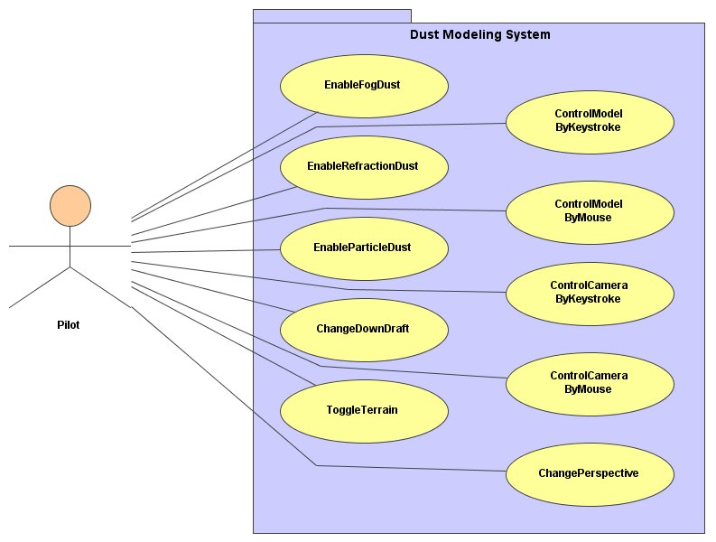
3.2 Detailed Use Cases

UC01: EnableFogDust (Enable Volumetric Fog Dust) – This use case enables the user to simulate the dust using the volumetric fog method. This might be the best-looking method.
UC02: EnableRefractionDust – This use case enables the user to simulate the dust using the light refraction method.
UC03: EnableParticleDust – This use case enables the user to simulate the dust using the particle dust method. This would most likely be more accurate but much slower than the other methods.
UC04: ChangeDownDraft – This use case allows the user to increase or decrease the amount of force (in the form of air currents) from the rotor blades acting on the dust.
UC05: ControlModel – This use case allows the user to move the helicopter model around in the simulation, which would again vary the amount and direction of force on the dust.
UC05.1: ControlModelbyKeyboard (keystroke) – This use case allows the user to control the locomotion of the model by use of the keyboard.
UC05.2: ControlModelbyMouse – This use case allows the user to control the locomotion of the model by use of the mouse.
UC06: ControlCamera – This use case allows the user to see the simulation from different points of view by enabling camera movement.
UC06.1 ControlCamerabyKeyboard – This use case allows the user to control the positioning of the camera by use of the keyboard.
UC06.2 ControlCamerabyMouse – This use case allows the user to control the positioning of the camera by use of the mouse.
UC06.3: ChangeCameraPerspective – This use case allows the user to change the camera perspective from 1st person to 3rd person and back again.
UC07: ToggleTerrain – This use case allows the user to choose between having and not having a terrain to run the simulation in. There could possibly be different terrains to choose from as well.

3.2 Detailed Use Cases (Continued)

Use Case: EnableFogDust
ID: UC01
Actors:
Pilot
Preconditions:
1. Fog Dust Technique is not already enabled
Flow of events:
1. Use case starts when user clicks “Enable Particle Dust Technique”

2. If particle dust technique is not already active

2.1 enable Particle Dust Technique
2.2 exit use case

3. System then refreshes using Particle Dust Technique

Postconditions:

Use Case: EnableRefractionDust
ID: UC02
Actors:
Pilot
Preconditions:
1. Refraction Dust Technique is not already enabled
Flow of events:
1. Use case starts when user clicks “Enable Refraction Dust Technique”

2. If refraction dust technique is not already active

2.1 enable Refraction Dust Technique
2.2 exit use case

3. System then refreshes using Refraction Dust Technique

Postconditions:

3.2 Detailed Use Cases (Continued)

Use Case: EnableParticleDust
ID: UC03
Actors:
Pilot
Preconditions:
1. Particle Dust Technique is not already enabled
Flow of events:
1. Use case starts when user clicks “Enable Particle Dust Technique

2. If particle dust simulation is not already active

2.1 Enable Particle Dust Technique
2.2 Exit use case

3. System then refreshes using Particle Dust Technique

Postconditions:

Use Case: ChangeDownDraft
ID: UC04
Actors:
Pilot
Preconditions:
1. Rotor blades of helicopter are moving
Flow of events:
1. use case starts when user clicks “Change Down Draft”

2. A slider appears and the user sets it to the desired speed of rotor blades.

3. If the user clicks up on the slider,
3.1 The downforce increases
3.2 Exit use case

4. If the user clicks down on the slider,
4.1 The downforce decreases
4.2 Exit use case

Postconditions:

3.2 Detailed Use Cases (Continued)
Use Case: ControlModelbyKeyboard
ID: UC05.1
Actors:
Pilot
Preconditions:
1. There is a vehicle on the screen.
2. Model Control: Keyboard is enabled.
Flow of events:
1. If the user presses the up arrow button,
1.1 The vehicle moves forward.
1.2 Exit use case

2. If the user presses the down arrow button,
2.1 The vehicle moves backward
2.2 Exit use case

3. If the user presses the left arrow button,
3.1 The vehicle moves left
3.2 Exit use case

4. If the user presses the right arrow button,
4.1 The vehicle moves right
4.2 Exit use case
Postconditions:

3.2 Detailed Use Cases (Continued)

Use Case: ControlModelbyMouse
ID: UC05.2
Actors:
Pilot
Preconditions:
1. There is a vehicle on the screen.
2. Model Control: Mouse is enabled.
Flow of events:
1. If the user moves the mouse up.
1.1 The vehicle moves forward.
1.2 Exit use case

2. If the user moves the mouse down,
2.1 The vehicle moves backward
2.2 Exit use case

3. If the user moves the mouse left,
3.1 The vehicle turns left
3.2 Exit use case

4. If the user moves the mouse right,
4.1 The vehicle turns right.
4.2 Exit use case

5. If the user presses and holds the right mouse button.
5.1 The vehicle is locked into strafing mode.
5.2 Exit use case
Postconditions:

3.2 Detailed Use Cases (Continued)

Use Case: ControlCamerabyKeyboard
ID: UC06.1
Actors:
Pilot
Preconditions:
Camera Keyboard Control is Enabled
Flow of events:
1. If the user presses the up arrow button,
1.1 The camera moves forward.
1.2 Exit use case

2. If the user presses the down arrow button,
2.1 The camera moves backward
2.2 Exit use case

3. If the user presses the left arrow button,
3.1 The camera moves left
3.2 Exit use case

4. If the user presses the right arrow button,
4.1 The camera moves right
4.2 Exit use case
Postconditions:

3.2 Detailed Use Cases (Continued)

Use Case: ControlCamerabyMouse
ID: UC06.2
Actors:
Pilot
Preconditions:
Camera Mouse control is Enabled
Flow of events:
1. If the user moves the mouse up.
1.1 The camera’s angle tilts up.
1.2 Exit use case

2. If the user moves the mouse down,
2.1 The camera’s angle tilts down
2.2 Exit use case

3. If the user moves the mouse left,
3.1 The camera’s angle rotates left.
3.2 Exit use case

4. If the user moves the mouse right,
4.1 The camera’s angle rotates right.
4.2 Exit use case

5. If the user presses and holds the right mouse button.
5.1 The camera is locked into strafing mode and can be moved laterally by mouse motion.
5.2 Exit use case
Postconditions:

3.2 Detailed Use Cases (Continued)

Use Case: ChangeCameraPerspective
ID: UC07
Actors:
Pilot
Preconditions:
1. None
Flow of events:
1. use cases starts when user presses “Tab” on the keyboard

2. If Perspective is currently first person.
2.1 Switches to Third Person
2.2 Exit use case

3. If Perspective is currently third person.
  - Switches to First Person
  - Exit use case

Postconditions: Camera Perspective is either first or third person.

3.2 Detailed Use Cases (Continued)

Use Case: ToggleTerrain
ID: UC07
Actors:
Pilot
Preconditions:
1. None
Flow of events:
1. use cases starts when user clicks “Toggle Terrain”

2. If terrain is enabled
2.1 Disable terrain
2.2 Exit use case

3. If terrain is disabled
  - Enable terrain
  - Exit use case

Postconditions: Terrain is either on or off

3.3 Scenarios

Use case: ControlModelByKeyboard

ID: UC05

Actor(s):
Pilot

Precondition(s):
1. The Pilot has chosen a helicopter as the model.

Primary scenario:
- The use case beings when the Pilot starts the simulation.
- The system will show the helicopter model on the ground.
- The Pilot must then start the engine of the helicopter.
- The system begins to simulate dust being scattered by the down-draft of the rotor blades.
- The Pilot can then use the controls to elevate the helicopter, which will determine the amount of dust being displaced.
- The Pilot can also use controls to turn the helicopter in a certain direction (e.g. left arrow key turns to the left, right arrow key to the right, etc.) and move around the terrain.
- The Pilot can then use controls to land the helicopter.

Secondary scenarios:
OutOfBounds

Postcondition(s):
3.3 Scenarios (Continued)

Use case: ControlModelByKeyboard
Secondary scenario:OutOfBounds

ID: UC05

Actor(s):
Pilot

Precondition(s):
1. The Pilot is flying the helicopter model.

Secondary scenario:
1. The use case begins in step 6 of the use case ControlModelByKeyboard when the Pilot attempts to fly out of bounds.
2. While the helicopter is in the air and the Pilot tries to use controls which would cause them to go out-of-bounds.
2.1 A warning message will be displayed announcing that the Pilot is out-of-bounds.
3. The system resets the position of the helicopter and the simulation must start over.

Postcondition(s):
.

Use case: ChangePerspective

ID: UC08

Actor(s):
Pilot

Precondition(s):
1. Locked-camera mode must be selected.

Primary scenario:
- The use case begins when the Pilot starts the simulation.
- Third-person perspective will be initial camera view.
- If Pilot presses “Change Perspective” button then first-person perspective will be initiated.
- Pilot can toggle between the two perspectives.

Postcondition(s):

Use case: ControlModelByKeyboard

ID: UC05

Actor(s):
Pilot

Precondition(s):
1. The Pilot has chosen a ground vehicle as the model.

Primary scenario:
- The use case beings when the Pilot starts the simulation.
- The system will show the ground vehicle model on the ground.
- The Pilot must then start the engine of the vehicle.
- The Pilot can then use the controls to move the vehicle in a certain direction (e.g. up arrow key moves forward, right arrow key steers to the right, etc.) and move around on the terrain.
- The system begins to simulate dust being kicked-up by the wheels and speed of the vehicle.
- The Pilot can then use controls to stop the vehicle.

Postcondition(s):

4 Requirement Traceability Matrix

The following is the requirement traceability matrix of the system’s requirements and use cases.

 |  | Use Case
 |  | UC01 | UC02 | UC03 | UC04 | UC05 | UC06 | UC07
Requirement | 1a | X
Requirement | 1b | X | X | X
Requirement | 1c | X | X | X
Requirement | 1d
Requirement | 2a
Requirement | 2b
Requirement | 2c |  |  |  |  |  | X
Requirement | 2d |  |  |  |  | X
Requirement | 2e |  |  |  |  | X
Requirement | 2f |  |  |  |  |  | X
Requirement | 3a |  |  |  |  | X | X
Requirement | 3b |  |  |  |  | X
Requirement | 3c |  |  |  |  | X
Requirement | 3d |  |  |  | X
Requirement | 3e |  |  |  |  |  |  | X
Requirement | 3f

5 User Interface

Here are three snapshots of the system’s user interface with brief descriptions.

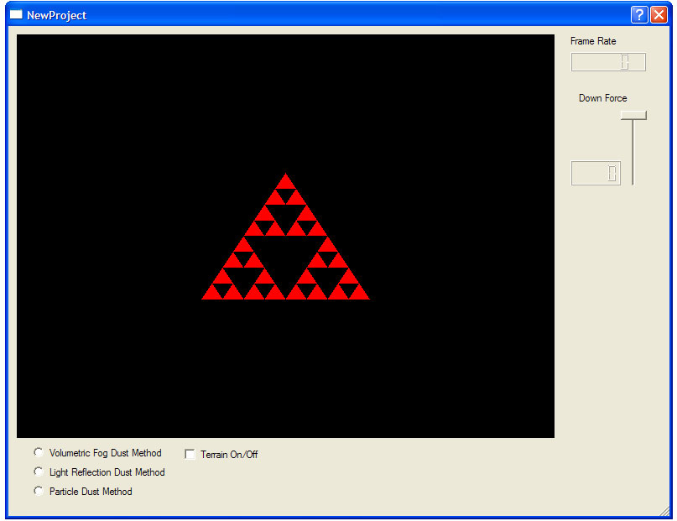

This will be the main window of our user interface.

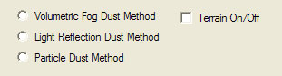

Here you will have options to choose from such as which Dust Method to simulate and whether or not to show the terrain.

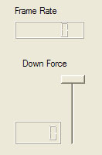

On the right-hand side of our interface will be options to change the down-force and it will also display the frame rate that the simulation is currently running at.

6 Glossary of Terms

Albedo - Albedo is the proportion of light reflected from a particle vs. light impinging on it, i.e. the reflectivity of the particle.

Anisotropic - Having physical properties that differ according to the direction of measurement.

Blending - OpenGL's mechanism for combining color already in the frame-buffer with the color of the incoming primitive.

Cave Automatic Virtual Environment (C.A.V.E.) – an immersive virtual reality facility designed for the exploration of and interaction with spatially engaging environments.

Diffuse Reflection – Reflection off of rough surfaces such as clothing, paper, gravel etc.

Down-draft – A relatively small-scale, downward moving current of air. In the context of this specification, that which is caused by a helicopter.

DRI - The Desert Research Institute (DRI) is the nonprofit research campus of the University and Community College System of Nevada (UCCSN), which is overseen by Interim Chancellor, Jim Rogers and a 13-member Board of Regents.

Lifetime (of particles) – Referring to the period of time between particle generation and destruction/disappearance.

NCSA (National Center for Supercomputing Applications) - a research center known for being a leader in developing innovative systems and software for science and engineering (such as C.A.V.E).

Oriented systems – systems that deal with how objects are oriented, or how objects move, such as deformable bodies, cloth, lava flow.

Particle System – A particle system is composed of one or more individual particles. Each of these particles has attributes that directly or indirectly effect the behavior of the particle or ultimately how and where the particle is rendered. Often, particles are graphical primitives such as points or lines, but they are not limited to this. Particle systems have also been used to represent complex group dynamics such as flocking birds. (http://www.cs.wpi.edu/~matt/courses/cs563/talks/psys.html)

Radiance – The amount of power passing in a given direction though a given surface per unit area (perpendicular to the direction of travel) per unit solid angle.

Rotor blades – the long airfoil that rotates to provide the lift that supports a helicopter in the air.

Specular Component – Glossiness and intensity of a diffuse reflection.

Stochastic systems – systems that use random and unstructured data to model objects which rely more on color and transparency such as dust, snow, fire, fireworks, smoke, etc.

Structured systems – systems that are used to model objects based around shape such as trees, water drops, leaves, grass, etc.

Transparency – Referring to the alpha value of the OpenGL blending function, which will determine the thickness of our fog.

Virtual Environment - a computer-generated, three-dimensional representation of a setting in which the user of the technology perceives themselves to be and within which interaction takes place; also called virtual landscape, virtual space, virtual world.

Volumetric Fog – The technique of applying fog to a confined spatial volume, as opposed to the tradition form of fog which is applied to a whole scene.

Voxel (volumetric pixel) - The basic unit of computed tomography reconstruction, represented as a pixel in a computed tomography image display. Voxel processing is a means of visualizing 3-dimensional shapes and structures implied by a series of cross-sectional images.

7 References

The CAVE at NCSA. http://cave.ncsa.uiuc.edu/

Dictionary.com. http://dictionary.reference.com/

Angel Edward., (2003) Interactive Computer Graphics: A Top-Down Approach Using OpenGL. Pearson Education.

(Description: This is our domain resource book. It covers many of the basic and advanced concepts surrounding computer graphics using OpenGL. This book was used as the primary text in the University of Nevada Reno’s Computer Science 480: Computer Graphics class. It is a book all members of the team are familiar with.)

Blinn, James F., (July 1982) Light Reflection Functions for the Simulation of Clouds and Dusty Surfaces. Jet Propulsion Laboratory, California Institute of Technology.

(Description: It concerns the statistical simulation of light passing through and being reflected by clouds of similar small particles. (It does not, however, address the cloud structure modeling problem). By extension it can be applied to surfaces completely covered by dust and is therefore a physical basis for various theories of diffuse reflection.)

Chen, Jim X., et. al. (1999). Real-Time Simulation of Dust Behavior Generated by a Fast Traveling Vehicle. ACM Transactions on Modeling and Computer Simulation, Vol. 9, No. 2, 81-104. (Reference Paper)

(Description: The article describes work done by researchers from George Mason University on dust simulation. They explore dust generation by the tires of a moving vehicle and the subsequent paths of the particles back to the ground. They also use blur, blending, and textures to replace the particles later on for more realism.)

Lewis, Robert R. (February, 1998). Light-Driven Global Illumination with a Wavelet Representation of Light Transport. University of British Colombia.

(Description: This thesis considers the problem of global illumination: the modeling of light as it travels through a scene interacting with the objects contained within the scene. It defines and details many illumination techniques and models (such as Phong) in the field of computer graphics.)

Martin, Allen., Particle Systems http://www.cs.wpi.edu/~matt/courses/cs563/talks/psys.html

(Description: This short but concise article describes particle systems on a very basic level, including origins of the term, basic definitions and details 3 different particles systems. The descriptions that the article gives about particles systems are described in the context of 3 modeling methods, modeling fire, trees, and a flock of birds.)

8 Contribution of Team Members

Marcos Bagby : Introduction, requirements specification, use cases, use case diagram scenarios, glossary of terms.
Ryan Romero : Requirements specification, use cases, scenarios, glossary of terms.
Brett Sulprizio : Requirements specification, use cases, UI design, traceability matrix, glossary of terms.
Hiroko Uda : Requirements specification, report template, traceability matrix, use case diagram, glossary of terms.

