Parsers and Grammars
a seminar by

University of Nevada, Reno chapter Association of Computing Machinery

Brian Westphal

Part I: General Discussion

Overview:
This seminar and collection of notes is geared towards those that have experience with computational theory, though no formal training is required. This seminar will cover the design and implementations of a parser generator and parser utility classes. All code is presented in Java, which is used for its simplicity. This seminar extends the information given in my NFA & RE Seminar and so it is important, for this purpose, to understand finite state automata and regular expressions.

What is a Parser/Parser Generator?
Given a grammar, or set of basic language rules, it is possible to create a program that is able to split up large collections of data into simpler, smaller, and more meaningful pieces. A parser generator is a program that takes much of the work of actually writing such a program away from the programmer. This is useful (and possible) because parsers generally contain large amount of repeated and similar code. Much of this code is used to describe the grammar. The rest is easily templated to take care of program overhead. Of course, once a parser generator builds the parser, the work is not over. In fact, that is when the work for programmers really begins.
A grammar, most typically, will be described using BNF or EBNF notation. Our parser generator will accept EBNF (Extended Bachus Naur Form) notation. As example of a grammar, following is a simplified grammar for English (a language you most likely already know).

English ::= Sentence*
Sentence ::= (Article S)? Noun S Verb S (Preposition S)? (Article S)? Noun '/.'
Article ::= 'a' | 'an' | 'the'
Noun ::= 'house' | 'car' | 'person'
Verb ::= 'plays' | 'sits' | 'goes'
Preposition ::= 'on' | 'over' | 'above'
S ::= ' '

As you might be able to see already, the sentence “a person sits on the car.” would be an acceptable example of English, using this grammar. The parser generator would take this grammar and build a program that can determine just this. A nice feature of our parser is that it will return the contents of parsed data in a tree structure. For instance, the previously mentioned sentence would be represented as follows (drawn without whitespace or period representation for simplification):
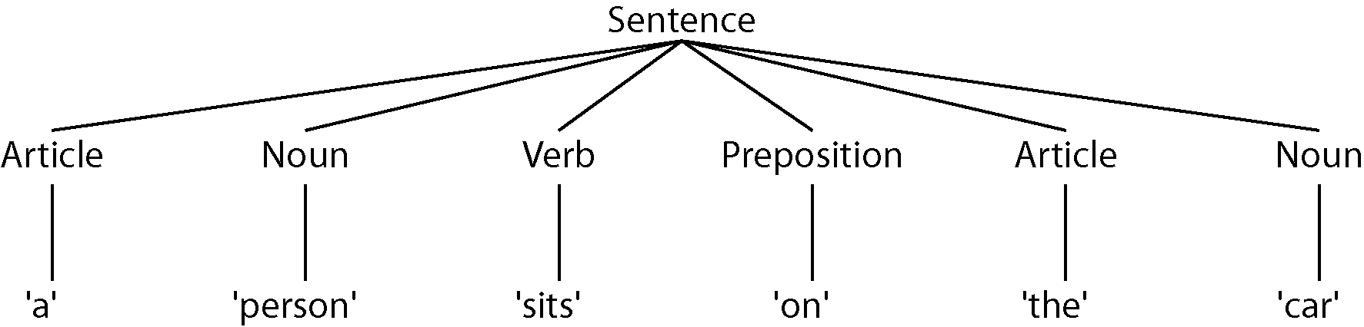
While this is a nearly trivial example, with a more realistic language the tree would become much more complex and also much more essential.

Part II: Discussion of Parser Utility Classes

Overall Design Goal:
Several classes in addition to the RegularExpression package and ParserGenerator class are needed to implement a parser. The first will be a simple tree structure (RETree), as was previously mentioned, that stores information describing the syntax of the grammar as it applies to a given string of input. Three other classes are also needed to process regular expressions as they apply to productions (each rule of a grammar is called a production). These three classes will be called REProcessor, SubProductionProcessor, and ProductionProcessor. Each of these, from left to right, gets progressively more complicated.

Designing an RETree Class:
In terms of code, the RETree class is relatively straightforward. The class contains only two properties and performs only tasks for convenience. The data each node of an RETree stores represents the branches and type of tree. Not all nodes have types and not all branches are trees.
The branches property is of type Object, but for the sake of actual use is restricted to two data types. These data types are String and LinkedList. When a branch is represented as a string, it denotes a simple regular expression match. In the example in part I, the ‘a’, ‘person’, ‘sits’, etc. nodes represent strings. The other nodes that clearly branch have LinkedList data type representations for the branches property. Each Object type element of such a linked list is of type String or RETree, continuing the tree structure.
In order to know the rule that a portion of a tree is matching, the RETree class uses a type property that is a string. This is particularly useful for printing the contents of an RETree or when using the RETree for parsing. Examples of types, using the example in part I are, ‘Sentence’, ‘Article’, and ‘Noun’.
There are several convenience functions that should be implemented in the RETree class. These include the standard toString function as well as collapse and size. The toString function returns the tree in text form denoting type whenever possible. The collapse function is similar to the toString function except that it does not include any tree formatting or type specifications. It is essentially the same as collapsing all of the data in a tree into the single string that matches the tree type. This is better served by the following example.
If a number is a collection of digits and a digit is 0-9, the grammer might look like the following.

Number ::= Digit+
Digit ::= [0-9]

Given the RETree that matches Number to the string “123”, the toString statement would return:
Number: [Digit: 1, Digit: 2, Digit: 3]
While this is a useful representation for debugging, it is not particularly useful for normal use. When a parser needs to extract data from Number it might be better represented as the entire string “123”, so running collapse on the RETree that matches Number to the string “123” would return “123”.
The last convenience function is size. It in effect returns the string length of the result of the collapse function.

Designing an REProcessor Class:
REProcessor is the base class for SubProductionProcessor and ProductionProcessor so it provides basic and fundamental support for the parser. An REProcessor will be used to perfom operations on regular expressions. Unary operations that can be achieved with an REProcessor include star, plus, maybe, and follow. These could be represented by A*, A+, A?, or A (which is the unary version of follow). These operations can also be applied to REProcessors. This effectively allows operations to be applied to groups of regular expressions. The binary operations include andnot, or, and follow which can be represented by A-B, A|B, and AB (which is the binary version of follow).
As should seem necessary, an instance of REProcessor holds two Object type variables, A and B, that represent the RE(s) and/or REProcessor(s) to be operated upon. An int mode variable is also kept to store which operation is needed.
Providing a foundation for other REProcessor based classes, REProcessor contains two useful functions that are overridden by existing subclasses. The beginningMatches function is used to determine, as is in the case of the RE class, whether the beginning of an input string matches the REProcessor (or group of regular expressions represented by the REProcessor). The evaluate function is used to determine whether a particular machine, A or B, matches the beginning of the input. The beginningMatches function performs the bulk of the work in the class as it handles the mode operations.
Though the operation andnot is not regarded as a regular operation it is as simple as other operations to implement using the REProcessor. With certain binary operations (andnot and or) it is necessary to check two machines against the input string “simultaneously”. For instance, A andnot B matches successfully if and only if A matches the beginning of an input string and B does not match the same section. The binary follow and all unary operations are slightly simpler in that they only require checking a single machine in each moment.

Designing a SubProductionProcessor Class:
A subproduction should be thought of as a sub-rule as a subproduction is essentially a larger rule broken into smaller, more manageable pieces. While the code for the SubProductionProcessor class is much shorter than for REProcessor, it addresses some complicated issues that REProcessor does not need to. SubProductionProcessor is a subclass of REProcessor but adds functionality to handle productions, without knowing anything about their specific forms. SubProductionProcessor adds a type specifier and an array of SubProductionProcessors to the data in REProcessor.
The array of SubProductionProcessors allows for simplification of recursively complex production and subproduction definitions by referring to SubProductionProcessors (which may include ProductionProcessors) by number. Because all arrays are passed by reference in Java (as in C/C++), it is also important that not all productions need to be initialized in the list as long as a number is associated to each ProductionProcessor that will exist.

Designing a ProductionProcessor Class:

