AUTHOR REGISTRATION FORM - SEDE-2012
JUNE 27-29, 2012 Omni LA Hotel at California Plaza, Los Angeles, CA, USA
All registration materials must be received by May 25, 2012 for your paper(s) to be published in the proceedings.
Please complete this form (TYPE or PRINT) and return before May 25, 2012.
PAPER # _128_ Number of Pages __7___________
FIRST Name _Frederick_ MI _C_ LAST Name _Harris__
Title ( ◻ Dr. ) and (◻ Mr.) Position _Professor_ Organization _University of Nevada, Reno_
Address _Dept. of Computer Science & Engineering MS 171_
City _Reno_ State/Province _NV_ Zip/Postal Code _89557_ Country _USA_
Telephone _775-784-6571_ Fax _775-784-1877__
E-mail __Fred.Harris@cse.unr.edu__ List your areas of interest ______________________________
PLEASE NOTE: NON-MEMBERS who would like to become a NEW ISCA member at this time, or if you would like to renew your ISCA Membership at this time, please check both the ISCA MEMBER RATE * and the 2012 ISCA MEMBERSHIP** boxes below. (ISCA Membership is from January 1, 2012 through December 31, 2012)
ISCA MEMBER RATE * | $450.00 | __450____
NON-MEMBER | $550.00 | _________
2012 ISCA MEMBERSHIP ** | $100.00 | _________
ADDITIONAL FEES:
Extra page fee (per paper): | $ 60.00 / each page | __60_____
Additional PAPERS, if any: | 1/2 registration fee/ each | _________
Additional Luncheon Ticket: | $ 50.00 / each | _________
Additional SEDE-2012 Proceedings :
ISCA member | $ 50.00 / each | _________
Non-member | $ 70.00 / each | _________
Proceedings (BOOK format) can be ordered online at www.proceedings.com approximately two weeks after the conference.
 | TOTAL: | __510____
METHOD OF PAYMENT: __Check __Money Order __Visa _X_MasterCard
Payment may be made by check, International money order (in U.S. dollars drawn on a U.S. Bank made payable to ISCA), or credit card in U. S. Dollars.
Credit Card # 5405-0154-1818-6936
Expiration Date _07/13_ Security Number on Back of Credit Card __211_
Print Name as it appears on Card _Frederick C Harris, Jr_
Billing Street Address No. _1664 M Virginia St MS 171, Reno NV_ ZIP CODE of Billing Address _89557_
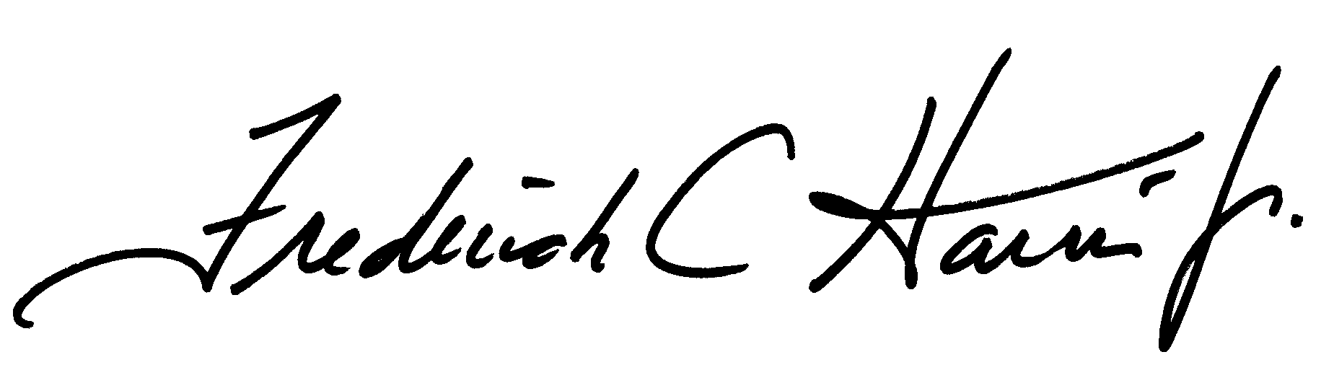
_________________________________________________________ (Signature REQUIRED)
(PLEASE INDICATE YOUR CHOICE BELOW)
I plan to attend the complimentary LUNCHEON on JUNE 28, 2012 ◻Yes
Special dietary requirements: _________________________

AUTHOR REGISTRATION FEE: An author may register one paper at this fee. See ADDITIONAL FEES (above) for more than 1 registered paper and extra page charges.
The conference full registration fee includes refreshments during the conference, a Luncheon banquet on JUNE 28, 2012, and one copy of the conference proceedings.
REGISTRATION FEES ARE NON-REFUNDABLE. Please email (as attachments) the (a) camera-ready manuscript with paper code in PDF format (example: SEDE207.pdf), (b) completed Registration Form with Fees, and (c) signed ISCA Copyright Form, and send to: Email: isca@ipass.net
EIN NO: 56-1799522
For any questions, please contact us via Email: isca@ipass.net or phone: (507) 458-4517;

