Dean Hinton,

You asked for two pieces of information from me. First my current salary. This past calendar year I earned $174,662 from the University of Nevada. That can be found on my W2 which is below.

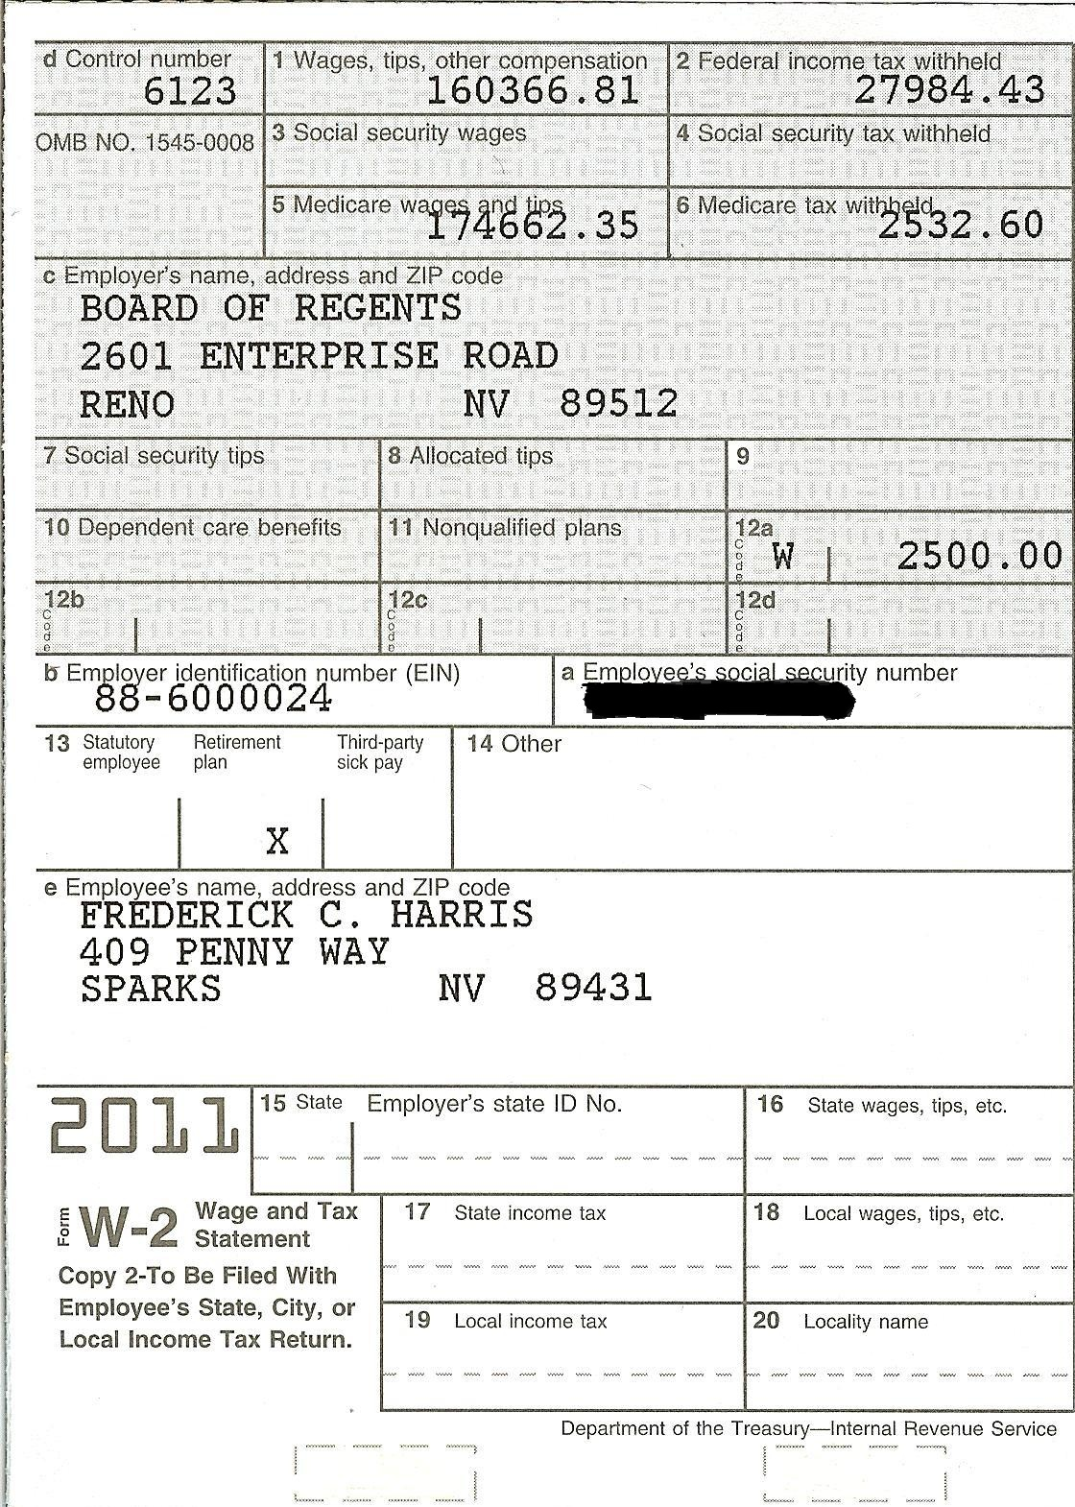

Second you asked for my personal research startup needs. In going through the evaluation of my startup needs, I thought it would be best to put down what my research work currently has, and then think about what would be appropriate with a different work load. So I am going to list my current space and computing resources along with my current students under supervision.

Current:
- Space
  - Office
    - SEM 240A – 294 sq ft
  - Research Labs
    - AB 632/638 – 796 sq ft
    - ARF 118/120 – 564 sq ft

- Computing
  - Office
    - Workstation (Core 2 Quad, 2 24” monitors, 8GB, 1TB) and UPS
    - Sony VAIO Z series Laptop w/ docking station (Core 2 Duo, 6GB, 128GB SSD, Dual video card, wifi, 3G)
    - iPad2 – 64GB wifi, 3G, kbd and accessories
    - BW Laser Printer

  - AB 632/638
    - 3 Workstations (6 core AMD Phenom, 2 24” monitors, 8GB, 1TB, Dual NVIDIA GTX 570) and UPS
    - 10 Workstations (Core 2 Quad, 2 24” monitors, 8GB, 1TB, Dual NVIDIA GTX 480) and UPS
    - 4 TB file server
    - BW Laser Printer
    - 52” Sony 3D TV
    - 120” Passive Stereo Wall (2 projectors, circular polarizing filters, mirror system)
    - Stereo Wall Render Machine (8GB, 1TB, Dual NVIDIA GTX 480)
    - 3D Tracking System – Opti-track (10 cameras)
    - Epson Ultra Short Throw projector w/ wireless transmission

  - ARF 118/120
    - 5 Workstations (6 core AMD Phenom, 2 24” monitors, 8GB, 1TB, NVIDIA GTX 460) and UPS
    - 3 Workstations (Core 2 Quad, 2 24” monitors, 8GB, 1TB, NVIDIA GTX 460) and UPS
    - 4 TB file server
    - 2 Lenovo laptop/tablets (1 with docking station)
    - Color Laser Printer
    - 2 BW Laser Printers
    - Epson Projector

  - Compute Cluster
    - 30 Dual Pentium III nodes (4 GB/node)
    - 34 Dual Pentium IV nodes (4GB/node)
    - 40 Dual Opteron nodes (4 GB/node)

    - 1-8 proc Opteron node (16GB/node)
    - 3-16 proc Opteron nodes (220GB/node)
    - 3-24 TB disk servers
    - Infiniband Network
    - 12-4 proc Opteron nodes (8GB)
    - 30-8 proc Opteron nodes (16GB)
    - Racks, and UPS’s for all

- Students
  - Funded
    - 2 Post Docs – one will take a new position May 1, the other is being promoted to Research Assistant Professor this spring. Hopefully this grant will come with me – and she will continue on it.
    - 2 PhD (1 Dec 2012 finish, other ???)
    - 3 MS (2 graduate Aug 2012, 1 graduates May 2013 will finish thesis this summer and have coursework left)
    - 10 undergrads (hourly)
    - Plus some others that are shared with another faculty member.

  - Unfunded (jobs elsewhere)
    - 4 MS
    - 2 PhD

Since my role statement will be changing drastically, my research involvement will also have to change.

Startup Needs:
- Space :
  - Office – will be provided
  - Lab space – for students and computers listed below.

- Computing :
  - Office: I need to replace my current equipment since it is UNR property and will have to stay in Reno.
    - Workstation
    - Laptop
    - iPad
  - Lab:
    - 4 Workstations – Dual Monitors, Dual NVIDIA 680s
  - Cluster:
    - I don’t know what computation capabilities there are at USU – so this is a piece I am not sure what to put here.

- Students: [to be used in the first 5 years]
  - RA Support – 2 per year for 3 years
  - Undergrad Hourly Support – 2 per year (10-20 hours per week) for 3 years.

- Travel Support: [to be used in the first 5 years]
  - 2 conference trips for me 1 for each student per year for 3 years.

I also thought I should let you know that I will be out of town until late Thursday night. There is an NSF EPSCoR Tri-State Conference (ID, NV, NM) this week that is supported by two grants that I am a part of. I should have email access and should be able to get to a phone if needed.

Fred Harris.

