Annual Report 2012

Principal Investigator:
Frederick C Harris, Jr, PhD, University of Nevada, Reno, USA (fred.harris@cse.unr.edu)
Co-Investigators:
Sergiu Dascalu, PhD, University of Nevada, Reno, USA
Henry Markram, PhD, Brain Mind Institute, Lausanne, Switzerland
Florian Mormann, MD, PhD, University of Bonn, Germany

Award: N000141010014 (start date: October 1, 2009)

Large-Scale Biologically Realistic Models of Brain Dynamics Applied to Intelligent Robotic Decision Making

Contents:
A. Overall Objectives
B. Technical Approach
C. Accomplishments
D. Publications and Completed Degrees
E. Future Work and Plan
F. Transition Plan
G. Cooperative Development and Collaboration

A. Overall Objectives

Our main goal is to sufficiently understand cortical and subcortical brain dynamics so that we can implement human-like intelligent behavior, especially decision making under conditions of emotional demand in real-time social robotics. We believe that this research could lead to a major revolution in our understanding of both brain detailed biological processes and higher functional mechanisms in relation to emotion and learning. Technological applications include robotic assistants, exploration under hazardous conditions, and decision support to humans in field settings. We envision the final product of this research to be a virtual 1-million neuron interactive robotic agent that navigates in an environment while interacting with humans at a socially intelligent level.

B. Technical Approach

We allocate our efforts along the following interdisciplinary fields, as shown in Figure 1:

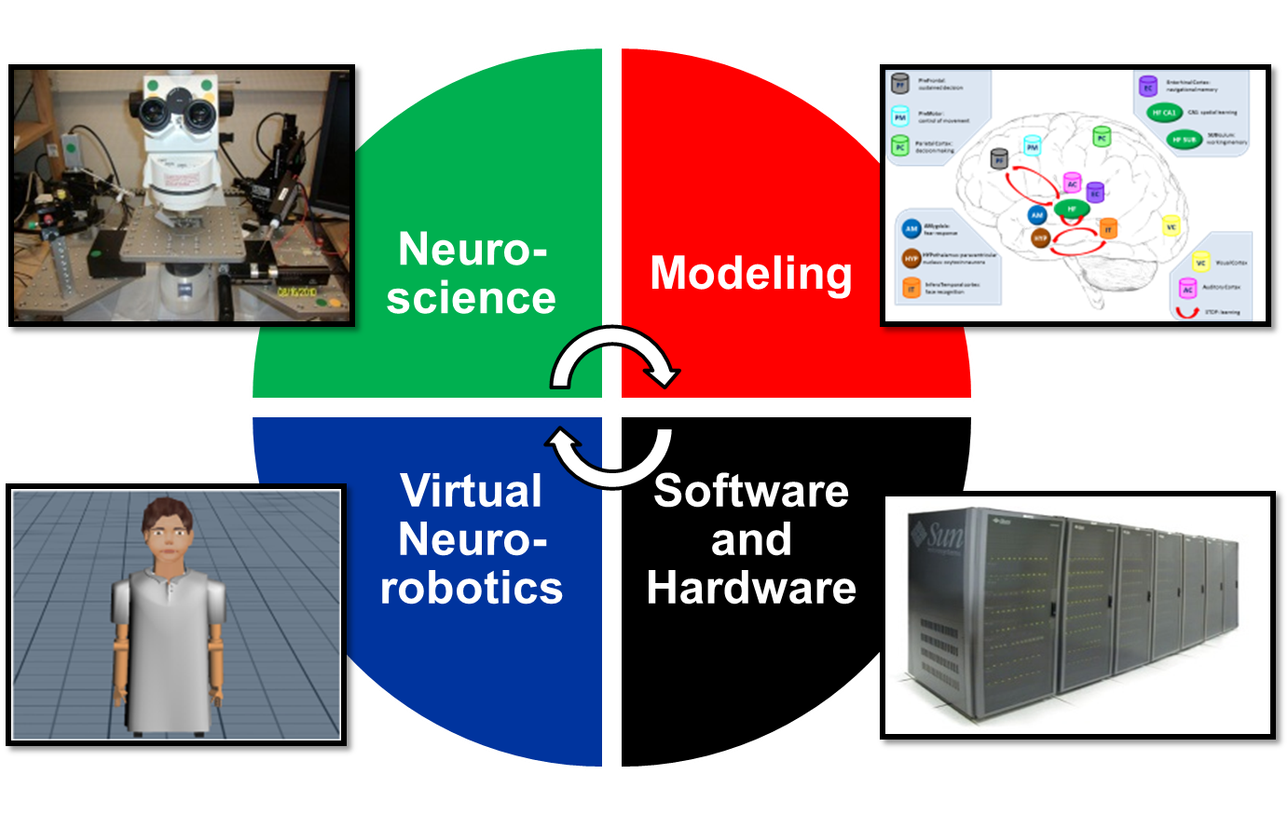

Figure 1: Brain Computational Research Overview

Experimental Neuroscience – Collecting and using recent and relevant in vivo and in vitro electrophysiological findings and apply them in our current models. Analyzing and comparing results to validate preliminary assumptions.

Modeling of Brain Dynamics - Understanding and creating neural microcircuitry that shows biologically-realistic mammalian-like brain dynamics, achieving nearly-instantaneous communication and regulation across all brain regions.

Virtual Neurorobotics (VNR) - Encoding and injecting robotic sensor data into brain modules, and converting spiking premotor activity to rate-based control of motor systems of emotionally-sensitive, decision-capable neurorobotics.

Computer Science Software/Hardware Infrastructure – Achieving high-level of performance and usability of a new version of our ONR-funded NeoCortical Simulator (NCS) and supporting tools for both scientists and developers. Using our new CPU/GPU/cluster-based simulator running on 16 NVIDIA GTX 480s to achieve real-time computation of simulated large-scale neuron models.

C. Accomplishments
Over the past year, we achieved the following specific objectives:
- Expand brain model to 1,000,000 cells
- Test robustness/functionality of the brain model
- Make a more complex decision making environment
- Reward-based Learning Through ESP
- Integrate it into a real-time virtual neurorobotic system
- Enhance/test/disseminate NCS version 6
- Create new supporting tools for NCS and VNR
- 1,000,000-neuron quasi-real-time robot brain

Several of these items are in preparation, in review or have been published in the past year. Appropriate references are listed below.

a. Brain Model Expansion and Improvement

Our updated model already contains many important biological-like features replicating dynamics in several areas of the brain, but additional important information can be simulated within the existing brain regions to make it even more realistic, as shown in Figure 2. The prefrontal cortex is the anterior part of the frontal lobe of the brain. The well-known role of the prefrontal cortex is its executive functions, such as working toward a defined goal, the prediction of outcomes, and more specifically, spatial working memory. Studies have shown “cooperativity” between hippocampal-prefrontal short-term and long-term plasticity. The premotor cortex is an area of the motor cortex lying within the frontal lobe of the brain. Any activity within this region is critical to the sensory guidance of movement and control of proximal and trunk muscles of the body. The parietal cortex is superior to the occipital lobe and posterior to the frontal lobe. It is responsible for integrating sensory input coming from various parts of the body and processing visuo-spatial information. The primary visual cortex is located in the occipital lobe where both the dorsal and the ventral streams originate. The dorsal stream sends information (motion, object locations) to the posterior parietal cortex and the ventral stream transmits signals (form recognition, visual landmarks) to the inferior temporal cortex. It is known that rodents automatically learn the spatial disposition of objects explored in an environment, and it is therefore possible that this automatic spatial learning element contributes to the hippocampal activity changes. The hippocampal formation is a neural structure in the medial temporal lobe mostly composed of CA1 and CA3 regions, the subiculum and the dentate gyrus. The importance of the hippocampus in spatial memory has long been recognized, and hippocampal damage impairs memory for all types of relations. The most commonly studied relationship of navigational behavior and electrophysiology in the hippocampus relates to the phenomena of place cells. The hippocampal formation allows for place recognition, strongly depends on visual input changes in a local environment, and stores the information that can accessed for any given position. Parahippocampal regions, including the entorhinal cortex, are located in the medial temporal lobe, adjacent to the hippocampus. The important role of the entorhinal cortex in memory and navigation has long been understood, with two main superficial layers, II and III. Recently, entorhinal grid cells were reported as part of a generalized path-integration-based map of the spatial environment in rats. Their firing pattern spans the environment in a remarkably regular triangular or hexagonal pattern and is thought to play a crucial function on the spatially confined activity of hippocampal place fields. The hypothalamus is located below the thalamus and above the brainstem. Its most important role is to connect the nervous system to the endocrine system via the pituitary gland. One common mechanism is dendritic oxytocin release into the hypothalamus, which is further directed to the pituitary gland for lactation and uterus contraction. However, recent studies showed that this mechanism was responsible for developing trust in humans. The amygdala is a component of the lymbic system located in the medial temporal lobe. It plays a prominent role in emotional reactions, particularly in the response of fear. During social interactions, oxytocin has a profound effect on amygdala. An increase in the level of this hormone would suppress the activity in amygdala, which is responsible for social cognition and fear in mammals. The infero-temporal cortex extends around the infero-lateral border on to the inferior surface of the temporal lobe. This region is one of the higher levels of the ventral stream of visual processing, associated with the representation of complex object features. These regions have been combined to interact with each other and form a functional and robust brain containing 1,000,000 neurons.

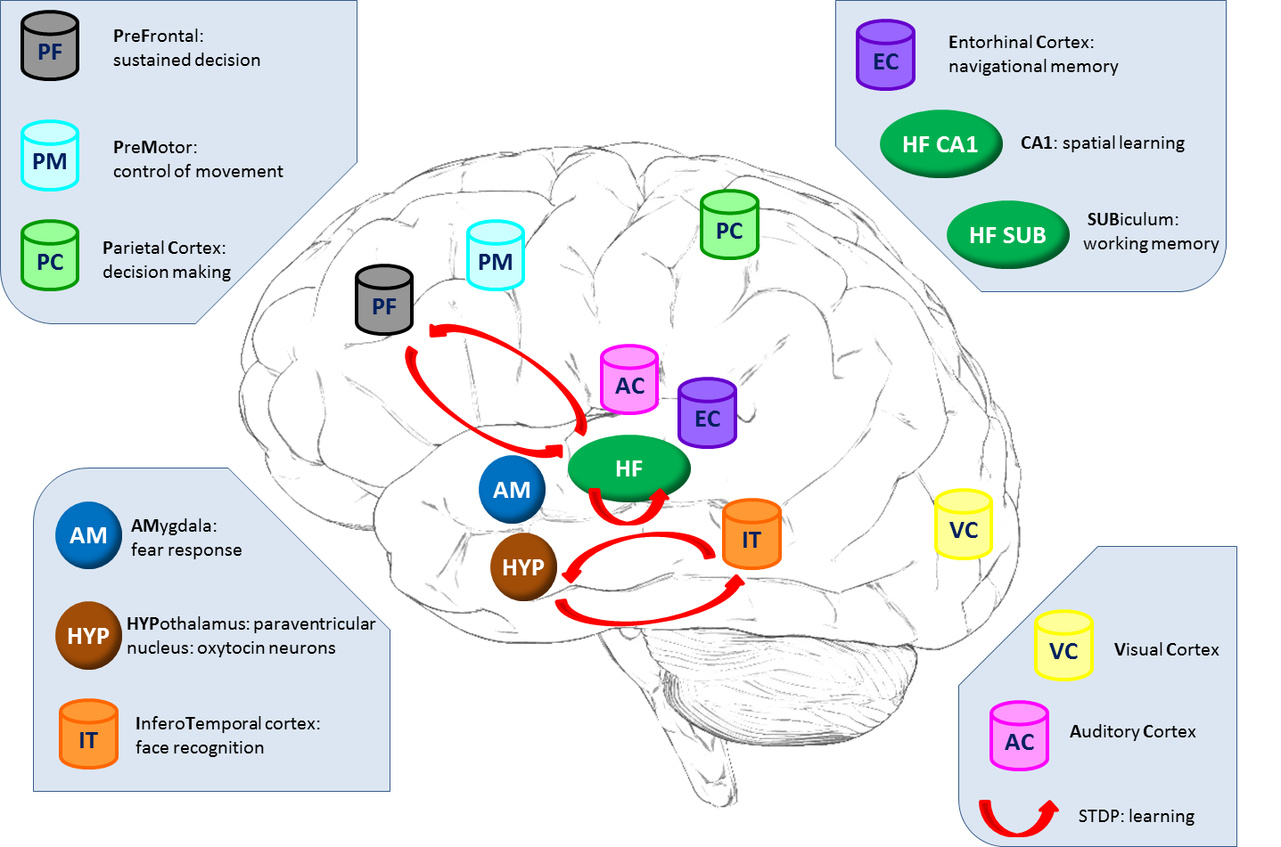

Figure 2: Already Modeled Brain Regions

Additional biological-like features replicating dynamics in several areas of the brain would improve our models’ functionality and robustness, as shown in Figure 3. The dorsal and ventral premotor cortices could be added to improve motor skills. Functional imaging studies have evidenced that, in humans, precision grasping activates a large bilateral network of fronto-parietal areas, including the ventral (PMv) and dorsal (PMd) premotor cortex. In monkeys, it has been suggested that PMd and PMv are part of two independent circuits, originating from the posterior parietal cortex and controlling, respectively, the reaching and grasping components of goal-directed hand movements. The basal ganglia could be added to improve cognitive and emotional functions. It has been shown to be involved in general functions, such as action selection, and learning reinforcement. Additionally, the understanding of the basal glanglia’s functions could be a great insight for the study of two neurological disorders, Parkinson’s disease and Huntington’s disease. The auditory cortex (and the visual cortex) could be added as an additional external cue for reward-based learning. It could be implemented with an emotional speech processing system which is starting to be used in social robotics as an auditory mode of reward or punishment following robotic behavior. It would be used to stimulate dopamine release from the brainstem, for reinforcement learning.

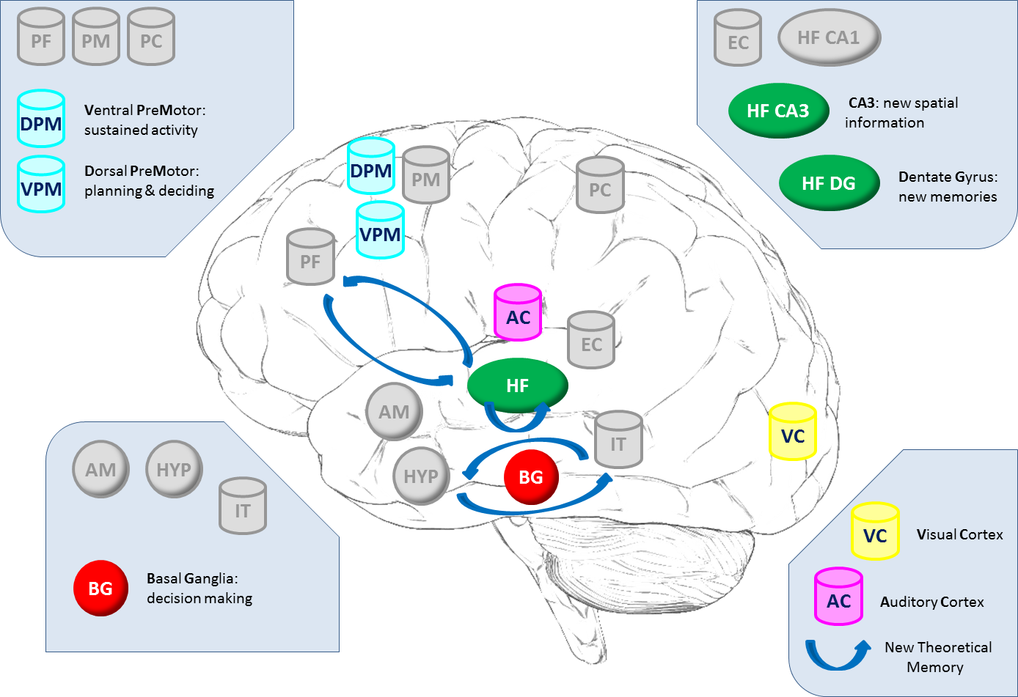

Figure 3: Brain Regions under Development

b. Robustness and Functionality of the models

Most of our day-to-day activities involve sequences of actions to navigate to a familiar location while utilizing visual landmarks. Exploring an environment and remembering the events that occur within it are crucial cognitive abilities that have been linked to the hippocampus and parahippocampal regions. In parallel, the prefrontal cortex is thought to be critical for goal-directed action and learning reinforcement. The members of the Brain Computation Laboratory at UNR have now a functional and robust large-scale biological model to understand brain dynamics during spatial navigation. The study has focused on understanding brain dynamics during spatial learning by modeling individual regions of the brain, such as the hippocampal, entorhinal and prefrontal loop. The model has been implicated in synaptic plasticity and memory and dynamic goal-directed behavior. Spike-timing-dependent plasticity (STDP) in the model induces cooperation between the hippocampus and the prefrontal cortex, and detailed modeling of distinct subicular populations allows reality of its role in the process.

The field of social robotics has been focused on better understanding the important dynamics of human emotion. For many decades, intelligent systems have tried to replace a human mind in planning, learning new functions, and making decisions, but some traits such as social skills have been hard to replicate. For this reason, it is tempting to try to incorporate realistic neuromorphic properties into machine learning systems. A variety of external cues are involved in trust, especially imitation. This recurrent mechanism has been shown in human behavior from early ages to adulthood and is associated with cooperation and trust. Therefore, we have also built another functional and robust large-scale biological model to understand brain dynamics during social interaction involving trust. It includes interacting brain regions, such as the visual, parietal, premotor and inferotemporal cortices, the hypothalamus, and the amygdala, and aim at understanding brain interaction during one type of common, but important social behavior, trust.

Hypothalamic oxytocin cells receive stimuli from columns in the visual, parietal, and inferotemporal cortices play a central role in this trust-inducing model. STDP is again used for learning. After learning with exposure to concordant motions, firing in the hypothalamus inhibits activity in the amygdala, which thus never shuts down the trust reaction in the parietal cortex. However, in the case of discordant motions during learning, there was little or no firing in the hypothalamus, so activity in the amygdala remains high and the trust reaction is suppressed.

c. Complex Decision Making Environment

A virtual robot (childbot) is placed in a starting position in a new virtual environment, which has 16 different scenarios of 4 binary decisions. It followed the length of the street until it reached the first intersection. Then it had to make a decision (left or right turn) based on the presented billboard (visual cue). Each intersection has a different patterned or colored sign as a visual landmark. The childbot visits the new environment until it becomes familiar and learns the correct sequence of turns to reach the goal. It can revisit the environment as many times as needed until it consistently succeeds. The success of reaching the goal reinforced its navigational learning. Note: the goal is located at 1 end of the 16 possible ones.

This is the first bio-inspired robot that shows high functionality while navigating in a complex environment and utilizing spiking cortical neurons in a real-time simulation.

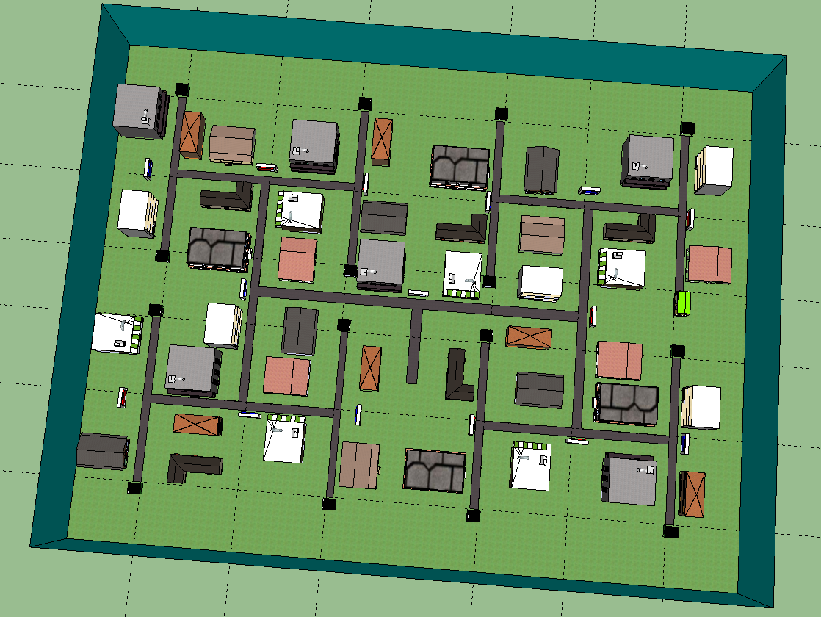

Figure 4: Complex Environment with Four Binary Decisions

d. Reward-based Learning through ESP

As a part of our neurorobotics, learning can be based on many different experiences including making correct decisions and consequently being rewarded. As illustrated in Figure 5: (1) a human participant presents the robot with one external cue at a time. The robot sees and then processes the information (2), then a decision followed by an action associated with the initial cue is made (3). Then, there are two possible scenarios (4): If the decision/action is incorrect, then the robot does not receive any reward. However, if the decision is correct it does receive a reward (e.g. hears positive speech) by the human. In our correct case, the reward stimulates synapses (in our simulated model) that underwent STDP. Every time the robot receives a spoken reward (5), the neural pathway corresponding to the correct decision and the action is reinforced (6) until completely learned.

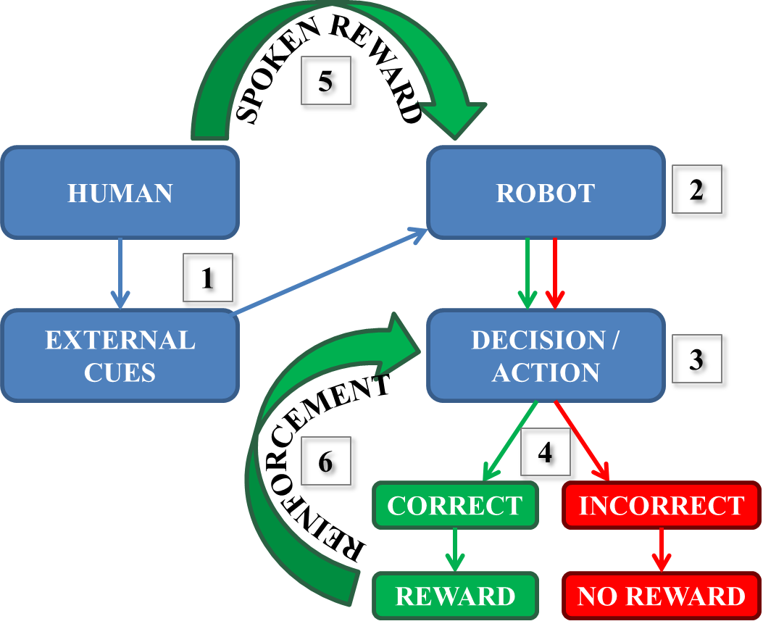

Figure 5: Reward-Based Learning Overview

For a high performance speech recognition system, the system operated in real-time by extracting several prosodic features for each utterance, and classifying them using the support vector machine library, libSVM. Samples were recorded twice with both “happy” and “sad” utterances giving a total of 160 phrase samples. For both experiments, the results were represented as confusion matrices distinguishing “happy” and “sad” utterances from both female and male speakers. These showed the accuracy of the system (in terms of % error) for both live and offline modes (Tables 1 and 2). During the offline mode, 92 samples] were used to train (31 samples) and test (61 samples) the system. As shown in Table 1, 33 phrase samples of the 34 total happy samples (male and female combined) were correctly classified as happy while one was classified incorrectly as sad, giving an error of 5.6%. Out of the 27 total sad phrase samples (male and female combined), 25 were classified correctly while two were incorrectly classified as happy, giving an error of 13.3%. If we separate the male and female results, all 16 of the happy male phrase samples were correctly classified as happy, giving a 0% error. All of the 12 sad female samples were also correctly classified as sad, giving an error of 0%. The overall average error for all 61 phrase samples was 4.7%, which corresponds to a system accuracy of 95.3%. Note: Approximately 33% of the total 160 samples were used to train the system. During the live mode, 160 samples from live recordings were used to train (83 samples) and test (77 samples) the system. As shown in Table 2, 41 phrase samples of the 42 total happy samples were correctly classified as happy while 1 was classified incorrectly as sad, giving an error of 5%. Out of the 35 total sad phrase samples, none were classified incorrectly, giving an error of 0%. The overall average error for all 77 phrase samples was 1.3%, which corresponds to a system accuracy of 98.7%. Note: Approximately 50% of the total 160 samples were used to train the system.

Category | Happy (M) | Sad (M) | Happy (F) | Sad (F) | Error (%)
Happy (M) | 16 | 0 | 0 | 0 | 0.0
Sad (M) | 2 | 13 | 0 | 0 | 13.3
Happy (F) | 0 | 0 | 17 | 1 | 5.6
Sad (F) | 0 | 0 | 0 | 12 | 0.0
Average Error (%) |  |  |  |  | 4.7

Table 1: Offline Mode Recognition Confusion Matrix

Category | Happy (M) | Sad (M) | Happy (F) | Sad (F) | Error (%)
Happy (M) | 22 | 0 | 0 | 0 | 0.0
Sad (M) | 0 | 16 | 0 | 0 | 0.0
Happy (F) | 0 | 0 | 19 | 1 | 5.0
Sad (F) | 0 | 0 | 0 | 19 | 0.0
Average Error (%) |  |  |  |  | 1.3

Table 2: Live Mode Recognition Confusion Matrix

e. Integration into a real-time virtual neurorobotic system

The virtual robotic system was designed around a number of components unique to our NeoCortical simulator (NCS) and our Virtual NeuroRobotic (VNR) paradigm as shown in Figures 6 and 7. The neural simulation was executed on a remote computing cluster and was networked to the other system components (NCSTools, Webots, Gabor filter) using our Brain Communication Server (BCS), a server developed specifically for integration with NCS.

In our navigation system, we have the following components: (A) Brain simulation using the Neocortical Simulator (NCS). (B) Brain Communication Server (BCS). (C) NCSTools provides real-time communication with running NCS. (D) Gabor filter provides a good representation of mammalian visual receptive fields. (E) Virtual Reality Modeling Language (VRML) model using Google Sketch (Environment) and Webots (Childbot). Overall, e created a bio-inspired robot that showed high functionality during navigation while utilizing spiking cortical neurons in a real-time simulation. Key interacting brain regions (hippocampus, and prefrontal, entorhinal, visual and premotor cortices), synaptic plasticity, and important dynamics were modeled for comprehending navigation and also special deficits in Alzheimer’s patients. Our virtual robotic interface mimicked human-like goal-related learning and navigational activities, which could also be useful for the field of machine-learning systems. This work will be presented at the of the month (July) at the conference of Computational Neuroscience in Atlanta/Decatur, GA.

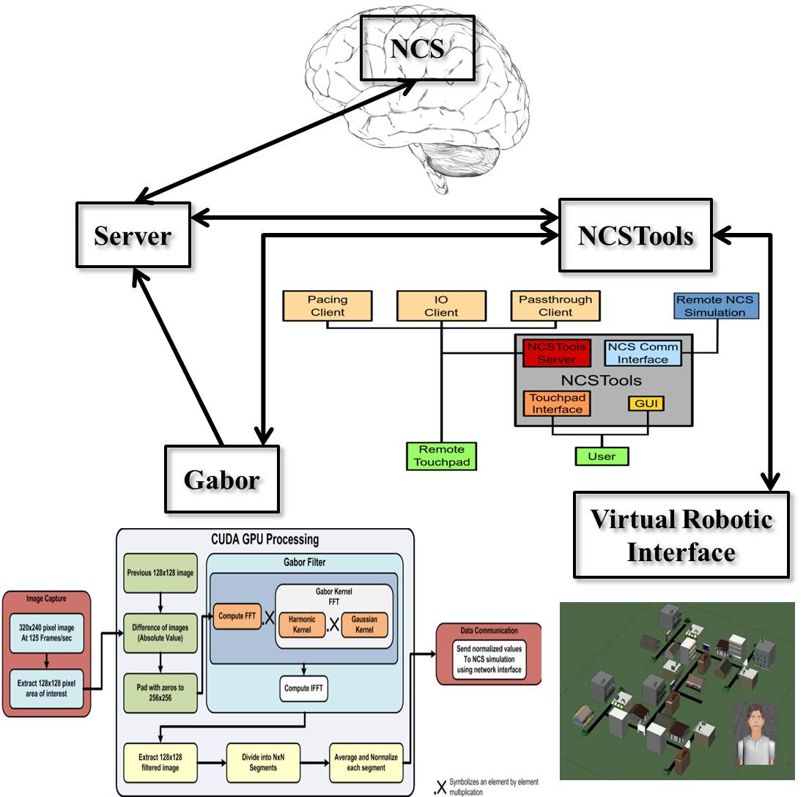

Figure 6: Navigation System Overview

In our reward learning system, we have the following components: (1) The external cue (red or blue card) is presented by the human to the neurorobot (via the camera); (2) The Information is processed by the neurorobot and is sent to NCSTools; (3a) NCSTools stimulates the appropriate regions of the modeled visual cortex; (3b) NCSTools server monitors the neurorobot and creates the appropriate stimulus to send to proprioceptive feedback and premotor movements; (4) This loop of events initiates the appropriate pointing motion/action toward a colored ball; (5) A spoken reward is given by coupling the output from the neurorobot with the ESP interface; (6) Via NCSTools, a reward stimulus is injected into the model to stimulate the corresponding synapses that are undergoing STDP, which reinforced learning. Overall, we described how our spoken reward system was successfully used as reinforcement learning and allow our childbot to learn a simple exercise and make ideal choices based on visual cues. This work is in preparation to be submitted in IEEE Transactions on Autonomous Mental Development.

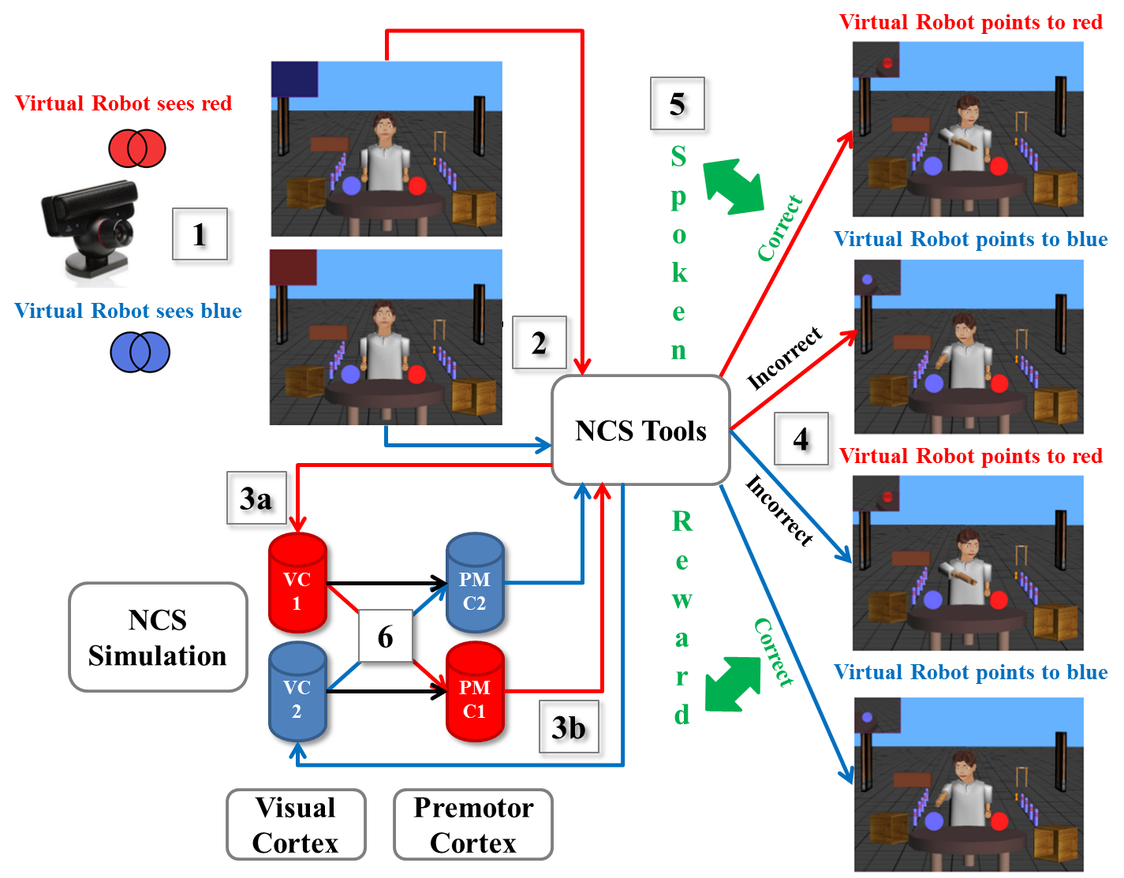

Figure 7: Reward-Based Learning System Overview

f. Enhance / Test / Disseminate NCS version 6
Software infrastructure:
We have finished the alpha version of NCS6. This implementation is a complete revision of NCS to run on a cluster of GPUs as well as a cluster of CPUs. This component based architecture will allow us to run models which are much larger. We currently have run models with more than 25,000,000 NCS5 synapses in real time. This implementation also allows us to model other types of synapses. We can model twice as many Izhikevich synapses in real time. This numbers are important because we now have the foundation for multiscale modeling, where part of the brain is modeled with one type of synapse and another with a different type of synapse. We feel that this will allow a variety of models which will allow us to explore intelligent decision making in real time. The end result is that we will produce a high performance general-purpose neural simulator for research in the basic, translational, and clinical neurosciences. We have also implemented CPU and GPU versions of these, and are looking at a CPU implementation of the Neuron engine.
Hardware infrastructure:
We reached a stage where the CPU only based simulation would not achieve the speedup we desired for the desired model sizes. This was compounded with the fact that we have increased the number of synapses per neuron to a more biologically realistic level. As we discussed in previous years, the three SUN Fire X4600 compute boards, each with 8 dual AMD processors, supported by a fourth head node Sun Fire X4500 (2007 DURIP) can support up to 10,000 neurons firing in real time each (for a total of 30,000 neurons). We determined that a larger cluster of these boards is needed for functional social robotics (or a transition to another architecture like GPUs). We submitted a DURIP 2011 proposal to build a hybrid system of SUN Fire X4600 boards augmented by GPU cards to achieve the 100,000 neuron model and the 1,000,000 neuron model in real time. This proposal was not successful, so we have continued with the multi-GPU architecture in the lab using the workstations in the lab (without using stand alone machines). At this point we have 1,000,000 synapses running in real time per NVidia 480 GPU on a workstations in our lab. We are looking at upgrading the GPUs in more machines to be able to run larger models in real time. They biggest bottleneck to this will be the connection between the machines (network) since standard lab networks are not designed for the high throughput and low latency that these simulations will require with larger models.

g. Supporting Tools for NCS and VNR
This past year the major tool developed in support of NCS and VNR has been NeuroTranslate. This tool translates between NCS input files and NeuroML files. Several software systems have been developed to simulate these processes with a wide range of biological detail, from the interaction between thousands of neurons, down to the dynamics between two individual cells. However, each uses a specific programming language or input syntax, which makes it difficult for non-programmers to use. Since each language is different, it also becomes a non-trivial task to compare results and exchange data among researchers, which slows down the discovery of important findings. We created a tool that translates input files between two different languages, the NCS input language and the NeuroML format. It provides a user-friendly interface, which can be used to both create and edit simulations without using a text editor or a complex programming language. This novel tool will not only allow non-programmers to model brain processes and functions, but will also give NCS users an opportunity to compare their modeling results with other well-known simulators.
This full-paper refereed work was presented in July at the 2012 International Conference on Software Engineering and Data Engineering in Los Angeles by two of the undergraduate students working in our lab.

h. 1,000,000-neuron quasi-real-time robot brain

As we mentioned under the software section, we have made great advances in the size of the models we are able to run. We have increased the number of synapses per neuron in order to make the models more biologically realistic. This prompted a major change in our assessment of model sizes. As we have measured over the last few years, most of the computation is at the synapse level with very little at the cell level. We can design 1,000,000 neuron models with very few synapses and have them run in real time or increase the number of synapses per neuron and make it more biologically realistic. We have developed a software framework that allows us to currently run low connectivity models of 1,000,000 cells on the GPUs in lab of workstations. We have also shown that we can run 50,000,000 Izhikevich neurons on the GPUs of 8 machines and 25,000,000 NCS neurons on the GPUs of the same 8 machines in real time.

The biggest shortcoming is the number and size of the GPUs as well as the interconnection network of the machines. We are hoping to upgrade the GPUs and Interconnect between them in order to decrease the latency between computers and therefore increase the size of our models.

D. Publications and Completed Degrees
Funding to date by the ONR Program in Computational Neuroscience, Brain Machine Interface and Human Robot Interaction has resulted in important progress toward our primary goal. Just over this past year (2011-2012), the funding contributed substantially to 5 journal publications, 9 conference papers and abstracts, 4 completed graduate degrees, 6 current graduate students, and 2 current undergraduate students and 1 CS senior project. Over the past three years (2009-2012), the funding contributed substantially to 10 journal publications, 18 conference papers and abstracts, 9 completed graduate degrees, and 3 CS senior projects.
- 2012 Journal Publications
- L. C. Jayet Bray, G. Ferheyhough, E. Barker, C. M. Thibeault, P. H. Goodman, and F. C. Harris, Jr.. Emotional speech processing in neurorobotics. In preparation, 2012.
- L. C. Jayet Bray, S. R. Anumandla, C. M. Thibeault, R. V. Hoang, P. H. Goodman, S.-M. Dascalu, B. D. Bryant, and F. C. Harris, Jr. Real-time human-robot interaction underlying neurorobotic trust and intent recognition. Neural Networks, 32:130-137, 2012.

- 2012 Conference Papers and Abstracts
- Q. Zou, L. C. Jayet Bray, P. H. Goodman, and F. C. Harris, Jr. The role of spatiotemporal correlations in the encoding and retrieval of synaptic patterns by stdp in recurrent spiking networks. In preparation, 2012
- L. C. Jayet Bray, E. R. Barker, G. B. Ferneyhough, R. V. Hoang, B. D. Bryant, S. M. Dascalu, and F. C. Harris, Jr. Goal-related navigation of a neuromorphic virtual robot. In Proc. of the 21st Annual Conference on Computational Neurosciences (CNS). Atlanta, GA, July 2012.
- L. C. Jayet Bray and F. C. Harris, Jr. Neocortical simulator (NCS) Tutorial. The 21st Annual Conference on Computational Neurosciences (CNS). Atlanta, GA, July 2012.
- N. Jordan, K. Perry, N. Narala, L. C. Jayet Bray, and F. C. Harris, Jr. Design and implementation of an NCS-NeuroML translator. In Proceedings of the International Conference on Software Engineering and Data Engineering (SEDE). Los Angeles, CA, June 2012.
- A. Breland, H. Singh, O. Tutakhil, M. Needham, D. Long, G. Hennig, R. Hoang, T. Loken, S. Dascalu, and F. C. Harris, Jr. In Proceedings of the Second International Conference on Advanced Computing and Communications (ACC). Los Angeles, CA, June 2012.
- Andrew Dittrich, Mehmet Gunes and Sergiu Dascalu, "Gathering Metrics from Software Repositories Using Network Analysis", 3rd Workshop on Complex Networks (CompleNet-2012), Melbourne, FL, USA, March 2012.
- C. M. Thibeault, J. Hegie, L. Jayet Bray, and F. C. Harris, Jr. Simplifying neurorobotic development with ncstools. In Proceedings of the 2012 Conference on Computers and Their Applications. Las Vegas, NV, March 2012.

- 2011 Journal Publications
  - L. C. Jayet Bray, C. M. Thibeault, J. A. Dorrity, B. D. Bryant, F. C. Harris, Jr., and P. H. Goodman. A microcircuitry of hippocampal, entorhinal and prefrontal loop dynamics during sequential learning. Frontiers in Computational Neuroscience, In review, 2011.
  - H. Markram, W. Gerstner, P. J. Sjöström. A history of spike-timing-dependent plasticity. Frontiers in Synaptic Neuroscience. 3:4, 2011.

- 2011 Conference Papers and Abstracts
  - S. R. Anumandla, L. C. Jayet Bray, C. M. Thibeault, R. V. Hoang, S. M. Dascalu, F. C. Harris, Jr., and P. H. Goodman. Modeling oxytocin induced neurorobotic trust and intent recognition in human robot interaction. In Proceedings of the International Joint Conference on Neural Networks (IJCNN). San Jose, CA, August 2011.
  - S. Dascalu, E. Fritzinger, S. Okamoto, and F. C. Harris, Jr. Towards a software framework for model interoperability. In Proceedings of IEEE 9th International Conference on Industrial Informatics (INDIN). Lisbon, Portugal, July 2011.
  - I. Gibbs, H. Ghazaleh, and S. Dascalu. Message Adaptor Code Generation. In Proceedings of the 9th IEEE International Conference on Industrial Informatics (INDIN), July 2011, Lisbon, Portugal, IEEE Computer Society, pp. 676-681.
  - S. Dascalu, E. Fritzinger, S. Okamoto, and F.C. Harris, Jr. Towards a Software Framework for Model Interoperability. In Proceedings of the 9th IEEE International Conf. on Industrial Informatics (INDIN), July 2011, Lisbon, Portugal, IEEE Computer Society, pp. 705-710.
  - C. M. Thibeault, R. V. Hoang, and F. C. Harris, Jr. A novel multi-GPU neural simulator. In Proc. of the 3rd Conference on Bioinformatics and Computational Biology (BICoB). New Orleans, LA, March 2011.
  - L. C. Jayet Bray, C. Thibeault, F. C. Harris, Jr., and P. H. Goodman. A circuit-level model of hippocampal and prefrontal dynamics. In Proc. of the Conference on Conputational and Systems Neuroscience (CoSyNe). Salt Lake City, UT, March 2011.

- 2011-2012 Completed Theses and Dissertations
  - Chad Feller (MS), Joseph Vesco (MS), Adrinne Breland (PhD), and Mukesh Motwani (PhD)

- 2009-2011 Completed Theses and Dissertations
  - Sridhar Anumandla (MS), Roger Hoang (MS), Laurence Jayet Bray (PhD), Sermsak Buntha (PhD), and Rakhi Motwani (PhD)
E. Future Work and Plan
We have several directions for our future work. The rest of this budget year we are running models on the new version of NCS as part of our brain model assessment, finishing up our new VNR based multi-decision model discussed earlier, and preparing our CNS tutorial on NCS6.
For the future we are planning on submitting a 3 year extension to this proposal with several topics:
- We plan on adding a structural visual cortex and auditory cortex for more complex decision making under emotional demand
- Combining “trust and navigation” learning brains into 1 super brain
- Improving NCS level of biological details
- Developing 2D and 3D visualization of the brain in action – firing patterns, sub-threshold voltage,… We feel that this will open the door for future neuroscience questions in the future
- Continue improvements on human-robot interaction based on auditory and visual cues
- Design and develop Input/Output/Robotic Tools which will make simulations available for more researchers at an easier level
- Disseminate Brain models and simulation programs
F. Transition Plan
Over this past year, we have started to focus on sharing NCS software and brain models with ONR and non-ONR investigators, we had good discussions with other PI’s at the June annual reporting meeting in Arlington regarding using NCS for their models. We have been selected to give a tutorial on our new version of NCS at one of the major computational neuroscience conferences: CNS, Atlanta/Decatur GA. The dissemination of our models will soon be stored in an online database, which will be available to all. Additionally, we are looking at NSF funding for the software engineering life cycle of NCS.
G. Cooperative Development and Collaborations
During the previous annual report our foreign collaboration had been on standby due to Dr. Goodman passing. However, this year we have reestablished contact with both of our collaborators (see below) via phones calls and emails. Additionally, Dr. Jayet Bray went to visit the Brain & Mind Institute this past May. The purpose of the visit was to meet Dr. Henry Markram, explore their facilities (laboratory, equipment…), and get updates on their current research and findings, and discuss future collaborations.

Brain & Mind institute, Lausanne, Switzerland

Investigator Henry Markram co-directs of the Brain and Mind Institute (BMI) of the Swiss Federal Institute of Technology, Lausanne (EPFL). Dr. Markram’s Laboratory of Microcircuit Neurosciences and Blue Brain Project continue multidimensional probes of brain complexity. Funding by this ONR project enables UNR investigators and Dr. Markram to continue overlapping basic science and modeling research, and to transfer knowledge gained from the detailed cellular Blue Brain environment to the larger-scale networks.

Clinic for Epileptology, University of Bonn, Germany

Investigator Florian Mormann has returned from his post-doctoral fellowship at Caltech (Christof Koch, supervisor) and UCLA (Itzhak Fried, supervisor). He is now a research scientist at the Clinic for Epilepsy at the University of Bonn, where he is funded to modify the human brain recording setup to match that of the UCLA single-unit recording approach. Dr. Mormann has been collecting his own human data. He has also been working on ongoing activity dynamics at rest and in response to sensory stimuli.

L. C. Jayet Bray, C. M. Thibeault, J. A. Dorrity, B. D. Bryant, F. C. Harris, Jr., and P. H. Goodman. A microcircuitry of hippocampal, entorhinal and prefrontal loop dynamics during sequential learning. Frontiers in Computational Neuroscience, In review, 2011.
L. C. Jayet Bray, S. R. Anumandla, C. M. Thibeault, R. V. Hoang, P. H. Goodman, S.-M. Dascalu, B. D. Bryant, and F. C. Harris, Jr. Real-time human-robot interaction underlying neurorobotic trust and intent recognition. Neural Networks, 32:130-137, 2012.
L. C. Jayet Bray, E. R. Barker, G. B. Ferneyhough, R. V. Hoang, B. D. Bryant, S. M. Dascalu, and F. C. Harris, Jr. Goal-related navigation of a neuromorphic virtual robot. In Proc. of the 21st Annual Conference on Computational Neurosciences (CNS). Atlanta, GA, July 2012.
C. M. Thibeault, J. Hegie, L. Jayet Bray, and F. C. Harris, Jr. Simplifying neurorobotic development with ncstools. In Proceedings of the 2012 Conference on Computers and Their Applications. Las Vegas, NV, March 2012.
L. C. Jayet Bray, E. R. Barker, G. B. Ferneyhough, R. V. Hoang, B. D. Bryant, S. M. Dascalu, and F. C. Harris, Jr. Goal-related navigation of a neuromorphic virtual robot. In Proc. of the 21st Annual Conference on Computational Neurosciences (CNS). Atlanta, GA, July 2012.
L. C. Jayet Bray, G. Ferheyhough, E. Barker, C. M. Thibeault, P. H. Goodman, and F. C. Harris, Jr.. Emotional speech processing in neurorobotics. In preparation, 2012.
L. C. Jayet Bray and F. C. Harris, Jr. Neocortical simulator (NCS) Tutorial. The 21st Annual Conference on Computational Neurosciences (CNS). Atlanta, GA, July 2012.

