CS 633 Computer Network

Final Project

Development of a Web-based Timesheet Management System using Java JDBC, Java Servlet and HTML/JavaScript

Zhang, Liyan
lzhang@cs.unr.edu

Summary

In this project, a web-based timesheet management system was developed and deployed. The system allows users to enter their work hours each day for a week from a browser. Manager of the system can view the timesheets filled by users from a browser, too. Following techniques were employed for this project:

Java JDBC for the database management operations
Java Servlets for server side processing
Microsoft Access for timesheet database management system
JavaScript for field entries' validation

The project was developed and deployed at a personal computer running Window 95. The web server used is Apache and Java Servlet
engine is Apache Jserv.

1. Introduction

In recent years, with the proliferation of internet, applications of web-based database systems increase significantly. As such, many different tools are developed for these web-based database management systems. During the development of a web-based database system, two major issues that have to be addressed are: 1) how to let server dynamically handle client requests, i.e. server side application 2) how to access database management systems such as Oracle, Sybase, Microsoft SQL etc. For the first issue, many different solutions are available such as CGI scripts, Server side plug-ins, Active Server Page, CORBA, Sun's Remote Method Invocation APIs (Application Programming Interface), Servlets as well as various third party propriety packages. For the second issue, callable APIs from database vendors and third party middlewares can be employed.

In this course project, a timesheet management system is developed to illustrate the usefulness of web-based database systems. The main functions of the system are, 1) to let legible users to enter/edit his/her weekly timesheet on line 2) to let managers of the system to access finished timesheets.

Our project is developed and deployed at a desktop PC using Windows 95. Database management systems for our project is Microsoft Access, for its wide availability. The server side codes are developed using Java JDBC APIs and Servlets APIs for Java applications' portability through platforms. All the web pages for this project are programmed using HTML/JavaScript.

2. Review of Servlets, JDBC, and JavaScript

2.1 Java Servlets

"A servlet is a small, pluggable extension to a server that enhances the server's functionality".^{[1]} The role of s servlet is to load Java class files that will give the server dynamic features. Servlets can run on any platforms running Java Virtual Machine (JVM) and inherits most of the features found in the Java Programming language. Among various server side technologies, servlets offers a number of advantages over other approaches, including portability, power, efficiency, endurance, safety, elegance, integration, extensibility and flexibility. ^{[1]}

1). Portability: Servlets are written in Java and conform to a well-defined and widely accepted API, they are highly portable across operating systems and across server implementations.
2). Power: Servlets can harness the full power of the core Java APIs: networking and URL access, multithreading, image manipulation, data compression, database connectivity, object serialization and plethora of third-party Java classes and JavaBeans components.
3). Efficiency and Endurance: Servlet invocation is highly efficient. Once a servlet is loaded, it generally remains in the server's memory as a single object instance. Thereafter, the server invokes the servlet to handle a request using a simple, lightweight method invocation. Multiple, concurrent request are handled by separate threads, so servlets are highly scalable.
4). Safety: Servlets are developed using Java and are running inside JVM. They are subjected to a Java security manager and various security measures can be enforced to keep the server and host machine safe.
5). Elegance: Servlet code is clean, object oriented, thanks to the well-designed Servlet API. Advanced operations, like cookie handling and session tracking, are abstracted into convenient classes.
6). Integration: Servlets are tightly integrated with the server. This integration allows a servlet to cooperate closely with the server. A servlet can use the server to translate file paths, perform logging, check authorization, and perform MIME type mapping.

2.2 JDBC API

The Java Database Connectivity (JDBC) is a set of Java classes that provide an interface to SQL database. It provides cross-DBMS connectivity to a wide range of SQL databases as well as access to other tabular data sources, such as spreadsheets or flat files. The JDBC API allows developers to take advantage of the Java platform's "Write Once, Run Anywhere" applicability for industrial strength, cross-platform applications that require access to enterprise data. With a JDBC technology-enabled driver, a developer can easily connect all corporate data even in a heterogeneous environment. ^{[2][3]} Right now, JDBC can be used to access every SQL database, including Oracle, Sybase, DB2, SQL server, Access, FoxBase, Paradox, Progress, SQLBase, and XDB. JDBC drivers are available through all the major database vendors.

JDBC is portable SQL Call Level Interface (CLI) written entirely in Java. It provides two major sets of interfaces: 1) an application interface that enables to access SQL services in a DBMS-independent manner, and 2) a driver interface that DBMS vendor must adapt to their particular databases. The JDBC API makes it possible to do three things: 1) Establish a connection with a database or access any tabular data source 2) Send SQL statements and 3) Process the results. Also, JDBC API 2.0 supports transaction management and stored procedures.

2.3 JavaScript

JavaScript is Netscape's cross-platform, object-oriented scripting language. ^{[4]} It can be used to create applications that run over the Internet. Core JavaScript contains a core set of objects, such as Array, Date, and Math, and a core set of language elements such as operators, control structures, and statements. Core JavaScript can be extended for a variety of purposes by supplementing it with additional objects: ^{[4]}

1). Client-side JavaScript extends the core language by supplying objects to control a browser (Navigator or another web browser) and its Document Object Model (DOM). Client-side extensions allow an application to place elements on an HTML form and respond to user events such as mouse clicks, form input, and page navigation.
2). Server-side JavaScript extends the core language by supplying objects relevant to running JavaScript on a server. Server-side extensions allow an application to communicate with a relational database, provide continuity of information from one invocation to another of the application, or perform file manipulations on a server.

Right now most of applications using JavaScript are client applications running in a browser to enhance the interaction between web pages and users.

3. Development tools for Implementation of timesheet management system

3.1 Timesheet database

Database management system employed for this web-based timesheet management is developed using Microsoft Access. The name for our database is timesheet.mdb and it contains three tables. user table is used to store the all the user information for the system. timesheet table is used to store weekly timesheets for all the users. manager table is used to keep the login information for the manager. Figure 1 shows the structure of the database and the relationship among three tables.

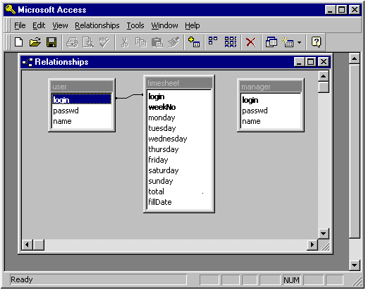

Figure 1. timesheet.mdb for the timesheet management system

3.2 Web Server for the project

All the web pages for this project are hosted at a PC running Windows 95 operating system. The web server used is Apache. The web server is freely available at http://www.apache.org. Our server is version 1.3.6.

3.3. JServ -- Servlet engine for running servlets from Apache web server

JServ is a Servlet engine developed by Apache group to run Java Servlet from Apache web server. It is free and features: ^{[5]}

1). 100% pure Java application allows complete portability of the servlet engine;
2). Works as a multi-threaded servlet server separated from web servers, to increase web server stability and save system resources;
3). Integrated load balancing features allow servlet serving power to scale with needs;
4). Smart redirection of requests allows load balancing request sessions the use of a specific network protocol (AJP) allows the creation of very complex network environments (many web servers connecting to many servlet engines on different machines);
5). Servlets may be separated into different logical containers (servlet zones) to ease servlet administration and allow context separation between different servlets;
6). Servlets may be run from a directory or an archive file (jar or zip). Servlets classes may be reloaded automatically when they are changed (autoreloading);
7). MD5 based connection authentication and connection IP filtering guarantees trusted servlet execution;
8). Easier administration with separated configuration files and dynamic web pages showing status and configurations;
9). Complete support for page compilation, Java server pages, server side include and template systems;
10). Extended logging and tracing capabilities for fine-tuning and debugging.

4. On-line timesheet management system

The start of the application calls the file final.htm. This page gives an introduction to our project and leads to the login page, login.htm, which in turns leads to two pages, userLogin.htm for users login and managerLogin for manager's login. userLogin page contains a form of three fields, login_name, password, and week number. A user needs to enter correct login name and password to use the system. One JavaScript program is included in the page to calculate the default week number for the convenience of the user. Another JavaScript program is used to verify the validity of user input. When a user hits submit button, three fields in the page is posted to a servlet, userLoginServ, which runs inside JServ engine by Apache web server.

userLoginServ servlet accepts input from userLogin.htm and check against Access timesheet.mdb to see if the user is a valid user, i.e. to check if the login name and password are in the user table of timesheet.mdb. The userLoginServ employs JDBC-ODBC driver to access timesheet.mdb. If the user is a valid user, the userLoginServ servlet generates a page containing a form (table) to let the user enter or edit his weekly timesheet. Within this page, there contains another servlet, timesheetServ, which writes user's timesheet input to the timesheet table of timesheet.mdb. If the login and password entered by the user is not contained in user table, a page of warning is generated and sent to the user's browser.

The managerLogin.htm page is used for manager's login. Like userLogin page, it also contains a form of three fields, login_name, password, and week number. A manager needs to enter correct login name and password to use the system. Two same JavaScript programs as those for userLogin.htm page are used to set up default week number and check the validity of login name and password. managerLoginServ servlet is used to accept input from managerLogin.htm and check against manager table of timesheet.mdb to see if the login name and password is correct. If yes, all the timesheets finished by users for the specific week number is returned as table format to the manager for him/her viewing. If there is no finished timesheet available, a message is sent to the manager. If the login information (login name and password) is not correct, a warning page is returned.

5. Deployment and test of the timesheet management system

The web site for the timesheet management system is located at http://paleo1.dri.edu/cs633/final.htm. For the test purpose, user table and manager table of timesheet.mdb database were filled with 5 and 2 record respectively. Table 1 and Table 2 show all the records in both tables. The timesheet.mdb needs to be registered to the operating system for the JDBC access.

login | passwd | name
john | computer | John Elway
lee | 556677 | Lee Tze Meng
lzhang | 112233 | Liyan Zhang
scott | javascript | Scott Fisher
xchai | abcdef | Xiaojun Chai

Table 1. Records in user table of timesheet.mdb database

login | passwd | name
cs633 | network | Dr. Looney
susan | ab12cd | Susan Diana

Table 2. Records in manager table of timesheet.mdb database

The main page (http://paleo1.dri.edu/cs633/final.htm ) of our project gives a brief introduction to our project and has a link to login page (http://paleo1.dri.edu/cs633/login.htm),which have to links for a user login and a manger login.

Figure 2(a), 2(b) and 2(c) show a legal user's interaction with the timesheet management system. After successful login (Figure 2(a)), user can fill his timesheet and submit it to the system (Figure 2(b)). If user's timesheet is successfully stored, a message is returned (Figure 2(c)).

Figure 3(a) and 3(b) show the screen shots for unsuccessful login of a user.

Figure 4(a) and 4(b) show a manager's interaction with the timesheet management system. After successful login (Figure 4(a)), a page with all the finished timesheet are displayed to manager (Figure 4(b)). If a manager's login is not success, a similar page like one shown on Figure 3(b) is generated and a warning message is sent out to the person who was trying to login into the system as manager.

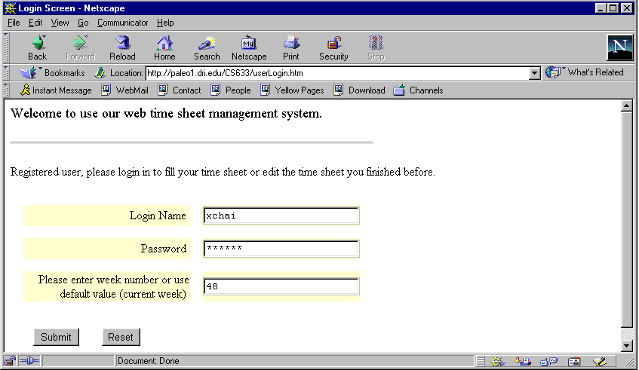

Figure 2(a). A user is logging into the timesheet management system, default week
number is 48.

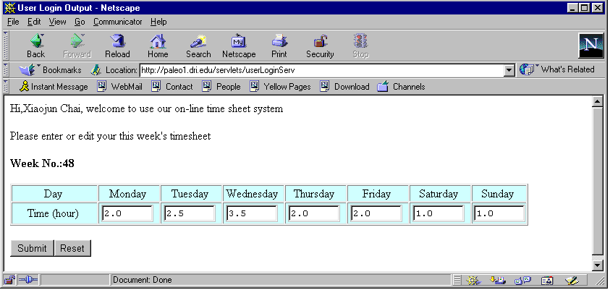

Figure 2(b). A user fills his work hours for the week

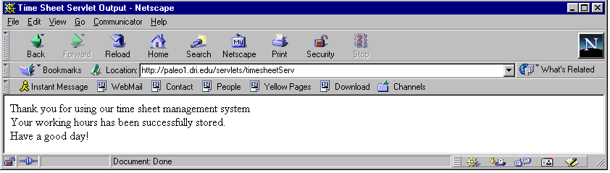
Figure 2(c). A message is sent back from server informing the user that his timesheet has
been successfully written to the system.

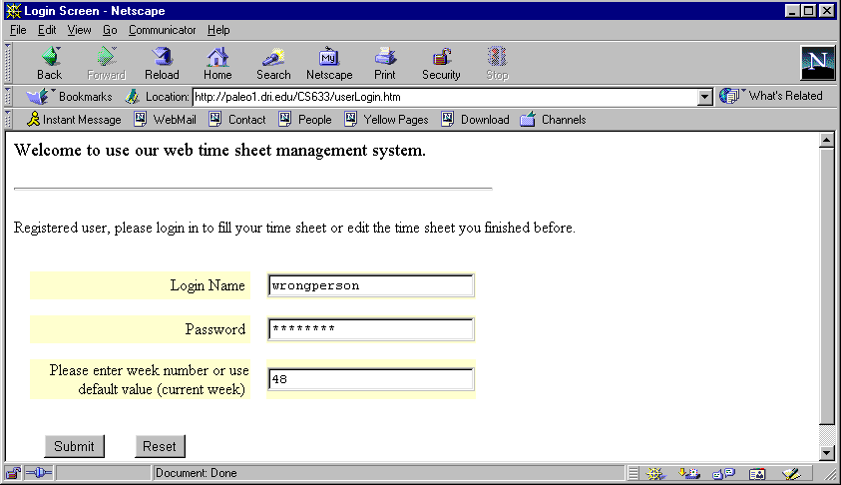

Figure 3(a). A "worngpersion" is trying to login into our system

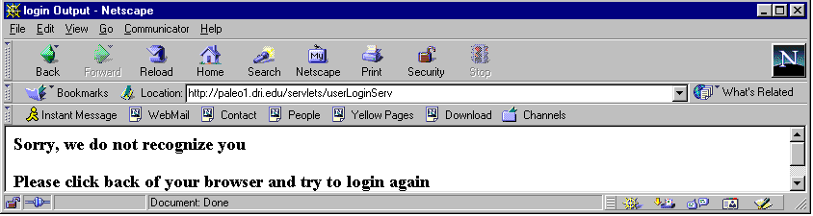
Figure 3(b). Login is not success
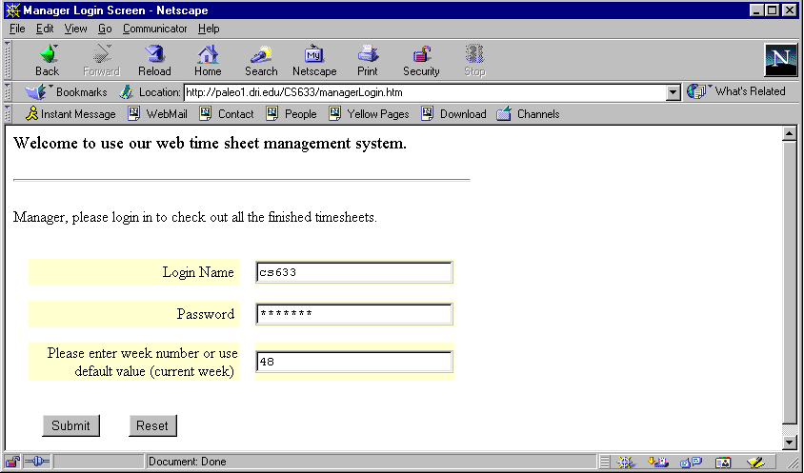
Figure 4(a). A manger is logging into the timesheet management system, default week is 48

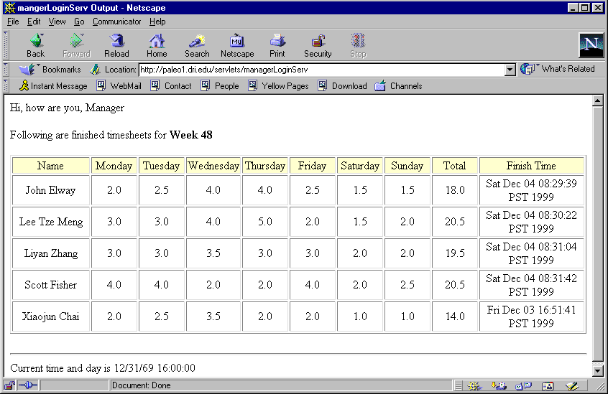
Figure 4(b). All finished timesheets are shown to the manager
5. Conclusions and Future work

In this final project, I implemented a web-based timesheet management system using what we have learned during class. The system was successfully developed and deployed on a PC running Windows 95, Apache web server and JServ Servlet engine. The database for this timesheet management system is developed using Microsoft Access. The server side codes are developed using Java JDBC APIs and Servlets APIs. All the web pages for this project are programmed using standard HTML/JavaScript.

Handling the timesheet is one of the time-consuming tasks for most of secretaries at departments. The timesheet management system developed for our final project has the potential to be used to facilitate the management of timesheet at department level. In order to evolve this primitive timesheet management system into a production system, future work can be done to add more functionality such as add/remove users on line, set up weekly hour limits etc., for the manager of the system.

Finally, I would like to express our sincere appreciation for Dr. Looney's instruction for our project. We have learned a lot through Dr. Looney's lectures and working on the project.

6. Reference:

[1]. Hunter, J., Crawford, W., Java Servlet Programming, O'Reilly & Association, Indianapolis,
Indiana, 1997.
[2]. Robert, O., Dan, H., Client/Server Programming with Java and CORBA, Wiley Computer
Publishing, 1998.
[3]. http://www.java.sun.com/products/jdbc/index.html
[4]. http://developer.netscape.com/docs/manuals/js/client/jsguide/index.htm
[5]. http://java.apache.org/

