Active Contour Model, Snake

Liyan Zhang
Department of Computer Science
University of Nevada, Reno
Lzhang@cs.unr.edu

Summary: The active contour model, or snake, is an energy-minimizing spline guided by external constraint forces and influenced by image forces that pull it toward features such as lines and edges ^{[3]}. It can interact with higher process or user. In this project, we implement a Java interface for user to draw initial contour and adjust the influence of different energy terms. We also regularize the parameters for paleontological specimen.

1. Introduction
Under the Marr’s paradigm ^{[5]}, low-level tasks such as line or edge detection have been treated as autonomous bottom-up processes. The rigidly sequential approach propagates mistakes made at a low-level image processing without opportunity for correction. Instead of imposing stringent demands on the reliability of low-level mechanisms, Kass, Witkin, and Terzopoulos^{[3]} proposed a set of alternative organizations among which higher-level processes may choose, rather than shackling them prematurely with a unique answer. The active contour model, or snake, is an energy-minimizing spline guided by external constraint forces and influenced by image forces that pull it toward features such as lines and edges. Snakes do not solve the entire problem of finding contours in images; rather, they depend on other mechanisms such as interaction with a user, interaction with some higher-level image understanding process, or information from image data adjacent in time or space^{[3]}. The most advantage of snake is that it is active and information from a higher level process can be used. Changes in high-level interpretation can exert forces on a snake as it continues its minimization. Differ from the traditional approach of detecting edges and then linking them, issues such as the connectivity of the contours and the presence of corners affect the energy functional and hence the detailed structure of the locally optimal contour. These issues can, in principle, be solved by very high-level computations.

In this paleontologic task, the choice of interpretation of edge mostly depends on expert knowledge. We did the following work:
- Implement a user interface to let the user draw an initial contour and adjust the weights. The snake provides low-level edge detection mechanism.
- Regularize the parameters to fit the specimen image.

2. The algorithm of the snake
The development of active contour models, or snakes, results from the work of Kass, Witkin, and Terzopoulos^{[3]}. The active contour model is defined by an energy function. The energy functional, which is minimized, is a weighted combination of internal and external forces. The internal forces emanate from the shape of the snake, while the external forces come from the image and/or from higher-level image understanding process. The solution is found using techniques of variational calculus. The energy function is defined as

E_{snake} = ∫₀ ¹ E_{snake}(V(s))ds
= ∫₀ ¹ E_{int}(V(s)) + E_{image}(V(s)) + E_{con}(V(s)) ds (1)

E_{int}(V(s)): represents the internal energy of the spline due to bending
E_{image}(V(s)): represents the image forces
E_{con}(V(s)): represents the external constraint force

Internal Energy:
E_{int} = (α(s)|V_{s}(s)|² + β(s)|V_{ss}(s)|²) / 2
The first-order term makes the snake act like a membrane
The second-order term makes it act like a thin plate.
The internal energy is composed of first-order term and second-order term. The first-order term, which controlled by α(s), adjusts the elasticity of the snake. The second-order term, which controlled by β(s), adjusts the stiffness of the snake.

Image Forces
E_{image} = w_{line} E_{line} + w_{edge} E_{edge} + w_{term} E_{term}

Line Functional
E_{line} = I(x, y)

Edge Functional
E_{edge} = - | ∇I(x, y)|²

E _{term} = ∂θ/∂n⊥ = (∂²θ/∂n²⊥ ) / (∂θ/∂n⊥ )

3. Greedy Algorithm

Amini et al.^{[1]} proposed an algorithm for the active contour model using dynamic programming. The approach is numerically stable. It also allows inclusion of hard constraints in addition to the soft constraints inherent in the formulation of the functional.

Donna et al. ^{[9]} pointed out that some of the problems with the two approaches and proposed the Greedy algorithm. The algorithm is faster than Amini’s O(nm³) algorithm, being O(nm) for a contour having n points which are allowed to move to any point in a neighborhood of size m at each iteration. In the function used in the algorithm is
E_{snake} = ∫₀ ¹ ( α(s)E_{cont} + β(s)E_{curv} + γE_{image}) ds
The form of the equation is similar to Eq.(1). The first terms is first-order continuity constraints and the second term is the second-order continuity constraints. They correspont to E_{int} in Eq. (1). The last term is the same as image force in Eq. (1). No term for external constraints was included here.

In this project, we use greedy algorithm.

Greedy Algorithm:

V^{(t)}_{i-1}

V_{i}^{(t-1)}
V^{(t-1)}_{i+1}

Figure 1. Local neighborhood search of the minimum

Pseudo-code for Greedy Algorithm:

Initialize α_{i}, β_{i}, and γ_{i} to 1 for all i.
Do
/* loop to move points to new locations */
for i=0 to n /* n = number of points in contour */
E _{min} = BIG
For j=0 to m-1 /* m is the size of neighborhood */
E_{j} = α_{i}E _{cont, j} + β_{i} E _{curt, j} + γ_{i} E _{image, j}
If E_{j} < E_{min} then
E_{min} = E_{j}
jmin = j

Move point vi to location jmin
If jmin is not current location, ptsmoved ++
Until ptsmoved < threshold
4. Regularization
The parameters α, β, and γ are used to balance the influence of the three terms. Their relative values, rather than absolute values, are significant. Adjusting α and β controls the relative importance of the membrane and thin-plate terms. The controlled continuity spline is a generalization of a Tikonov Stabilizer^{[8]} and is regarded as regularization.^{[6][7]}

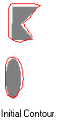
We regularize α and β, let β= 1- α, α = 0, 0.2, 0.4, 0.6, 0.8, 1.0, for γ=0.5, 1.0, 1.5

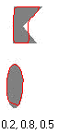

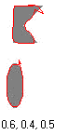

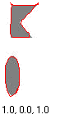

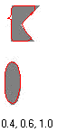
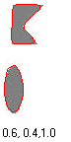
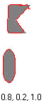
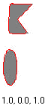
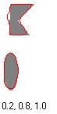
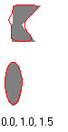



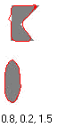


Figure 2. Regularization of parameters of the energy minimization function
Figure 2 shows the result of regularization, under each figure shows the (α,β,γ) value. When β = 0, the snake becomes second-order discontinuous and develops a corner. For the test images, when the image constraint is relatively large, the snake catches the edge very well. Since the real images have noise, we tried different parameters on them. We picked up parameters that can got good results for the test image from each row, then use the parameters for the real image. For the first row, we choose α=0.4, β = 0.6, γ = 0.5; the second row, α=0.6, β = 0.4, γ = 1; and the third row, α=0.2, β = 0.8, γ = 1.5.
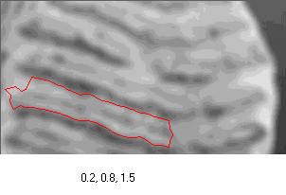

Figure 3. α=0.2, β = 0.8, γ = 1.5
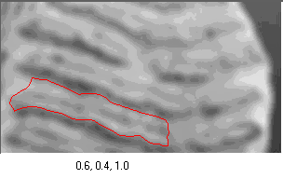

Figure 4. α=0.6, β = 0.4, γ = 1

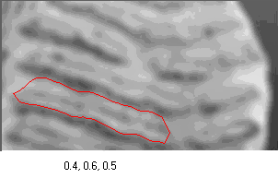
Figure 5. α=0.4, β = 0.6, γ = 0.5

For the real image, when the image constraint is relatively large, the snake catch the edge not as effectively as in test image, because it is extracted by noise or other lines. It is especially obvious at where the edge is broken. As shown in figure 4 at the left upper part of the snake. When the image constraint increases to 1.5, the snake is extracted even farther from the original place as shown on the left part of the snake in figure 3. Using α=0.4, β = 0.6, γ = 0.5, the snake can merge to the real edge and won’t go far from edge where the edge is broken or very weak. So we recommend α=0.4, β = 0.6, γ = 0.5 for paleontological specimens .

5. The application of snake:

In this application, we use Separable Model Architecture for the code structure.

5.1. Model-View-Controller (MVC) Architecture
MVC is an ideal way of modeling a component as three separate parts (Figure 6):
- The model that stores the data which defines the component
- The view that creates the visual representation of the component from the data in the model
- The controller that deals with user interaction with the component and modifies the model and/or the view in response to a user action as necessary.

model

Act on act on

controller
view
Act on

Figure 6. General Model-View-Controller Architecture

In object-oriented terms, each of the three logical parts for a component – the model, the view, and the controller – would ideally be represented by a different class type. In practice this turns out to be difficult because of the dependencies between the view and the controller.

5.2. Separable Model architecture

Since the user interacts with the physical representation of the component, the controller operation is highly dependent on the implementation of the view. For this reason the view and controller are typically represented by the single composite object that corresponds to a view with an integrated controller. In this case the MVC concept degenerates into the document/view architecture as shown in Figure 7. Sun call it the Separable Model architecture.

For this application as shown in Figure 8, Snake.class serves as the application object, that has overall responsibility for creating view, frame, model and managing links between them. The application object also acts as the communication channel between objects. Any object that has access to the application object will be able to communicate with any other object as long as the application class has methods to make each of the objects available.

View
(The look of the component)

Model
(Component Data)

Controller
(Deals with events making changes to the model or view)

Figure 7. Separable Model architecture

For this application, Snake.class is the application object, which has overall responsibility for creating view, frame, model and managing links between them. The application object also acts as the communication channel between objects. Any object that has access to the application object will be able to communicate with any other object as long as the application class has methods to make each of the objects available.
The SnakeView.class shows the view of the image and deals the interaction with uses. When user draws a contour, it will react and change the record in model. The SnakeFrame magages the view of the snake and reacts when user click command buttons such as ‘run’, ‘open’, ‘save’.
Application Object of Snake
(Snake.java)

creates creates
creates
Model Object
(SnakeModel.java)
Application Frame
(SnakeFrame.java)

displays changes to inserted into magages
the view the model the content pane the view

View Object
(SnakeView.java)

Figure 8. The Architecture of the application

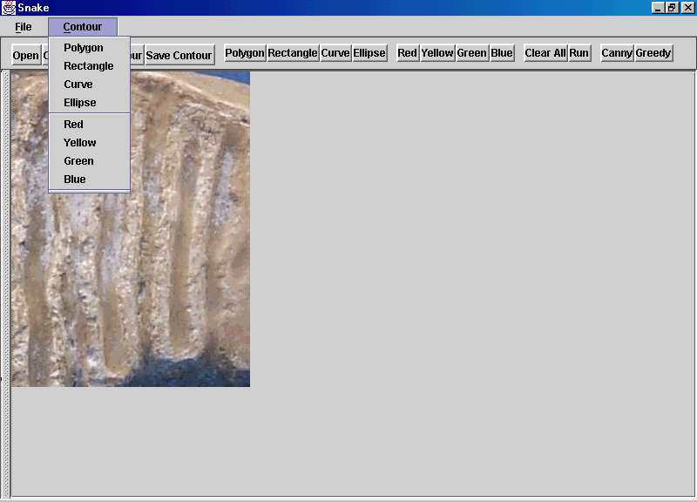
6. Interface of the Snake

Figure 9. User Interface

The buttons:
- Open: pop up a dialog for user to open new image files
- Close: close the application
- Save Contour: Pop up a dialog for user to save the contours on the interface
- Read Contour: Pop up a dialog for user to read contour file and show on the interface
- Polygon: Click points as vertices, double click to end.
- Rectangle: To draw a polygon, click one point as start point, drag and release the mouse.
- Curve: Free hand draw line
- Ellipse: Click one point as start point, drag and release the left mouse button
- Red, Yellow, Green and Blue: Specify the contour color
- Clear All: Clear all contours on the view.
- Run: Run the algorithm
- Canny: Pop up a dialog for change the canny parameters
- Gready: Pop up a dialog for change the Greedy parameters

7. Conclusion
Using snake for finding the tooth wedges is useful. The position of initial contour affects the result. We tried using diferent initial contour, if the initial contour is too far from the intended edge, the snake will slither away to another edge or line. We also tried to fix one or two parameters and then change the other, did not get as good as the one using regularization.

Reference
[1] A.A. Amini, T. E. Weymouth, and T. C. Jain, “Using Dynamic Programming for Solving Variational Problems in Vision”, IEEE Trans on Pattern Analysis and Machine Intelligence, vol. 12, no. 9, september 1990

[2] J. F. Canny, “A computational approach to edge detection.” IEEE Trans. Pattern Anal. Mach. Intelligence PAMI-8 (1986), 679-698

[3] M. Kass, A, Witkin, and D, Terzopoulos, “Snake: Active Contour Models”, International Journal of Computer Vision, vol. 1, no.4, pp321-331, 1988

[4] K. F. Lai “Deformable Contours: Modelling, Extraction, Detection and Classification.” University of Wisconsin-Madison, 1994

[5] D. Marr and H.K. Nishihara. “Visual information processing: Artificial Inelligence and the sensorium of sight.” TECHNOLOGY REVIEW. Vol. 81(1). October 1978.

[6] T. Poggio and V. Toree, “Ill-posed problems and regularization analysis in early vision.” PROC. AARPA Image Understanding Workshop, New Orlends, L.A. Baumann(ed.), pp. 257-263, 1984

[7] T. Poggio, V. Toree, and C. Koth, “Computational vision and regularization theory.” NATURE, vol. 317(6035). Pp. 314-319, 1985

[8] A.N. Tikhonov, “Regularization of incorrectly posed problems.” SOV. MATH. DOKL. Vol. 4, pp. 1624-1627. 1963

[9] D. J. Williams and M. Shah, “A Fast Algorithm for Active Contours and Curvature Estimation”, CVGIP: Image Understanding, vol. 55, no. 1, January, pp14-26, 1992

