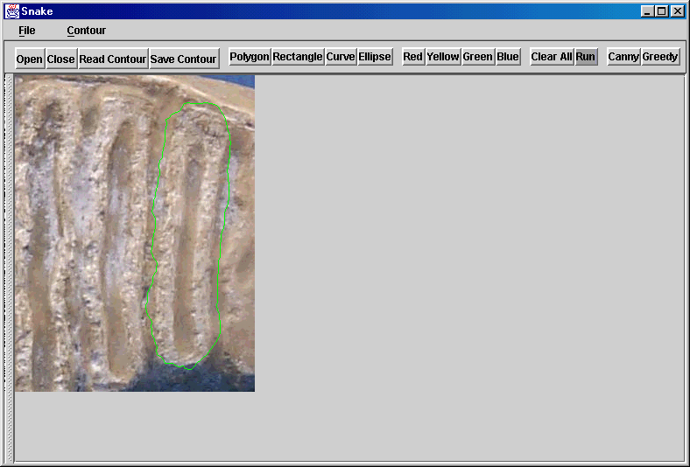
Figure 1. The interface of active contour application
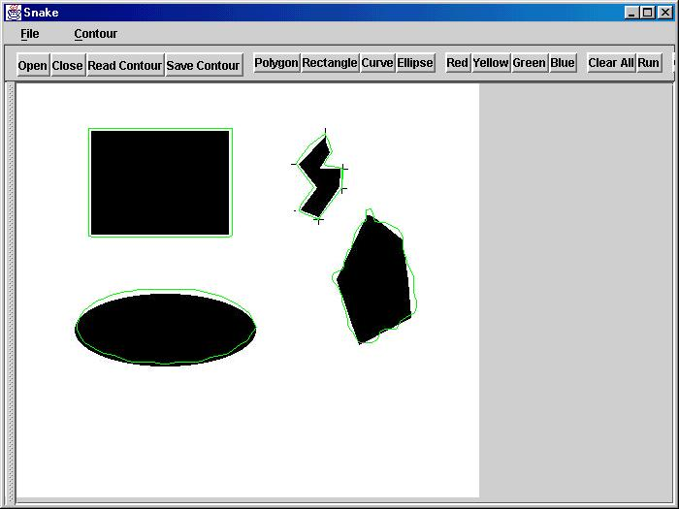
Figure 2. An example of the application, green lines are the contours user drew on the view.
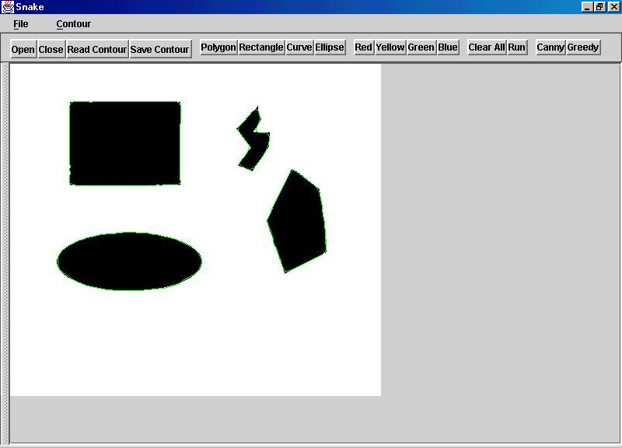
Figure 3. The result of figure 2, sigma=2.0, α=1.0, β=1.8, γ=1.7
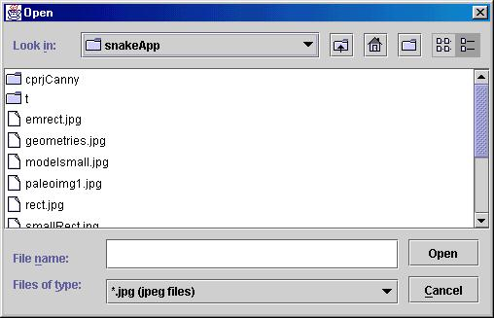
Figure 4. Open dialog

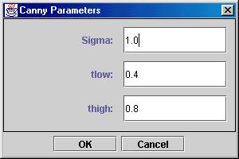

Figure 5. Set canny parameters

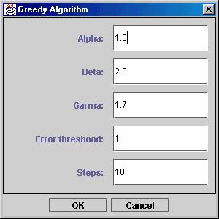
Figure 6. Set greedy paramet

